Table of Contents

1. Introduction 2

1.1 Objective of the Manual 2

1.2 Intended Audience 2

1.3 Organization of the manual 2

2. Getting Started in Revenue Leakage Platform 3

2.1 Login 3

3. Home Page 4

4. Dashboard 5

5. Facility Performance 8

5.1 BY Department 11

5.2 BY PATIENT TYPE 12

5.3 BY CHARGES 13

5.4 BY AUDITOR: 14

5.5 BY Financial class: 15

6. Auditor Performance 17

7. Supervision Tools 20

7.1 Live Summary 20

7.2 Auditor Assignment 22

7.3 Report User Assignment: 23

7.4 Additional auditor Queue List: 25

7.5 New Auditor Queue 27

7.6 Global Account Search 29

8. Auditor view 31

8.1 PRE-BILL ACCOUNT REVIEW LIST 31

8.2 POST-BILL ACCOUNT REVIEW LIST 34

8.3 Coding edits Accounts 37

8.4 View Confirmed charges 38

8.5 Edit Submitted Accounts 40

8.6 Submitted coding edits Accounts 42

9. Analysis 44

9.1 Hit rate Analysis 44

9.2 Volume Analysis 45

10. Configuration 46

10.1 Rules Summary 46

10.2 New Rule 48

10.3 Published Code List 50

10.4 Publish New Code 53

1.5 Update CDM 54

**1. Introduction**

Revenue Leakage application is an intuitive application that works with your hospital’s existing system to find missing charges in patient accounts. It provides a simple user interface that allows an administrator to evaluate a prioritized list of patient accounts, auditor performance report and provide feedback. As it uses advanced machine learning, it adapts automatically, which means administrator doesn’t have to update the system when rules and regulations change.

Using this application, administrator can evaluate the auditor’s performance by viewing the comparison report of different auditors. He is able to see all Pre-Bill and Post-Bill prediction accounts of different hospitals across the system. He is able to see all charges that are identified during auditing process for selected hospital(s) for the date range.

Another important function of Administrator is “User Management” which involves creating new users, modifying existing users, Enabling/Disabling the user accounts and resetting user passwords when needed.

The administrator is the privileged user who has the overall control of the application.

Revenue Leakage application is very user friendly and is an easy system to navigate.

1.1 Objective of the Manual

The objective of this manual is to provide assistance to the users ensuring effective use of the features and functionalities of the Revenue Leakage Platform application. The manual provides step-by-step descriptions of the functionality within the Dashboard, Facility performance, Auditor performance, Supervision tools, Edit Rules and User Management.

1.2 Intended Audience

This manual is intended for administrators and users of Revenue Leakage application. Access to the application is through the role and permission privileges

1.3 Organization of the manual

The Administrator User Guide includes the following chapters:

* Dashboard
* Facility Performance
* Auditor Performance
* Supervision Tools
* Edit Rules
* User Management

2. **Getting Started in Revenue Leakage Platform**

* 1. Login

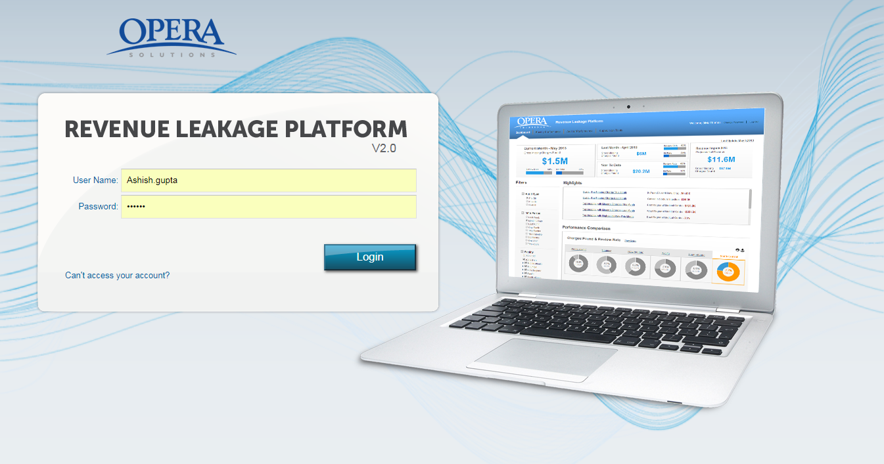

**Step 1:** The application can be accessed by entering the following URL into the address box:

_________________________________________

**Step 2:** Enter your “**Username”** and “**Password”**.

**Step 3:** Click “**Login”.**

**Step 4:** After entering the correct username and password, user is redirected to the Home page of Revenue Leakage Platform.

**Note:** Entering the wrong username and /or password three consecutive times will lock the account and then needs to be unlocked by other administrator.

1. **Home Page**

The Home page has following five tabs. By default, **“Dashboard”** tab is selected.

* + **Dashboard:** The Dashboard provides a detailed overview of auditing process of different hospitals across various divisions. You are able to view details like the Review Rate and the Missing Charges of various hospitals based on the filter criterion selected.
  + **Facility Performance:** The facility performance feature enables you to analyse the performance of various facilities based on departments, patient types, charges and auditors. You will be able to track information like Review Rate, Hit Rate and the Missing Charges for different hospitals.
  + **Auditor Performance:** The auditor’s performance feature enables you to view the performance of the auditors, compare the Review and Hit Rate of auditors as per the total facilities assigned to them.
  + **Supervision Tools:** The supervision tools enable you to perform various operations like assigning auditors and searching auditors by their name. In addition, you are also able to view the information for Pre-Bill, Post- Bill and Account Review List.
  + **Auditor View:** The Auditor view enable you to view all the tabs related to Auditor view. We can track the account information based on auditor selected.
  + **Analysis:** The Analysis view enables you to view Analysis based on Hit rate and Volume. We can select method type, auditor and top codes.
  + **Configuration:** These rules are predefined in the Revenue Leakage application and help in getting better results for the various Missing Charges found across various hospitals.

1. **Dashboard**

The Dashboard provides a powerful way to gain visibility and oversight into performance. You are able to analyse the efficiency of auditing process of different hospitals across various divisions. Based on the dashboard metrics, you can take proactive actions and can easily switch between different views of the data by selecting different filter parameters.

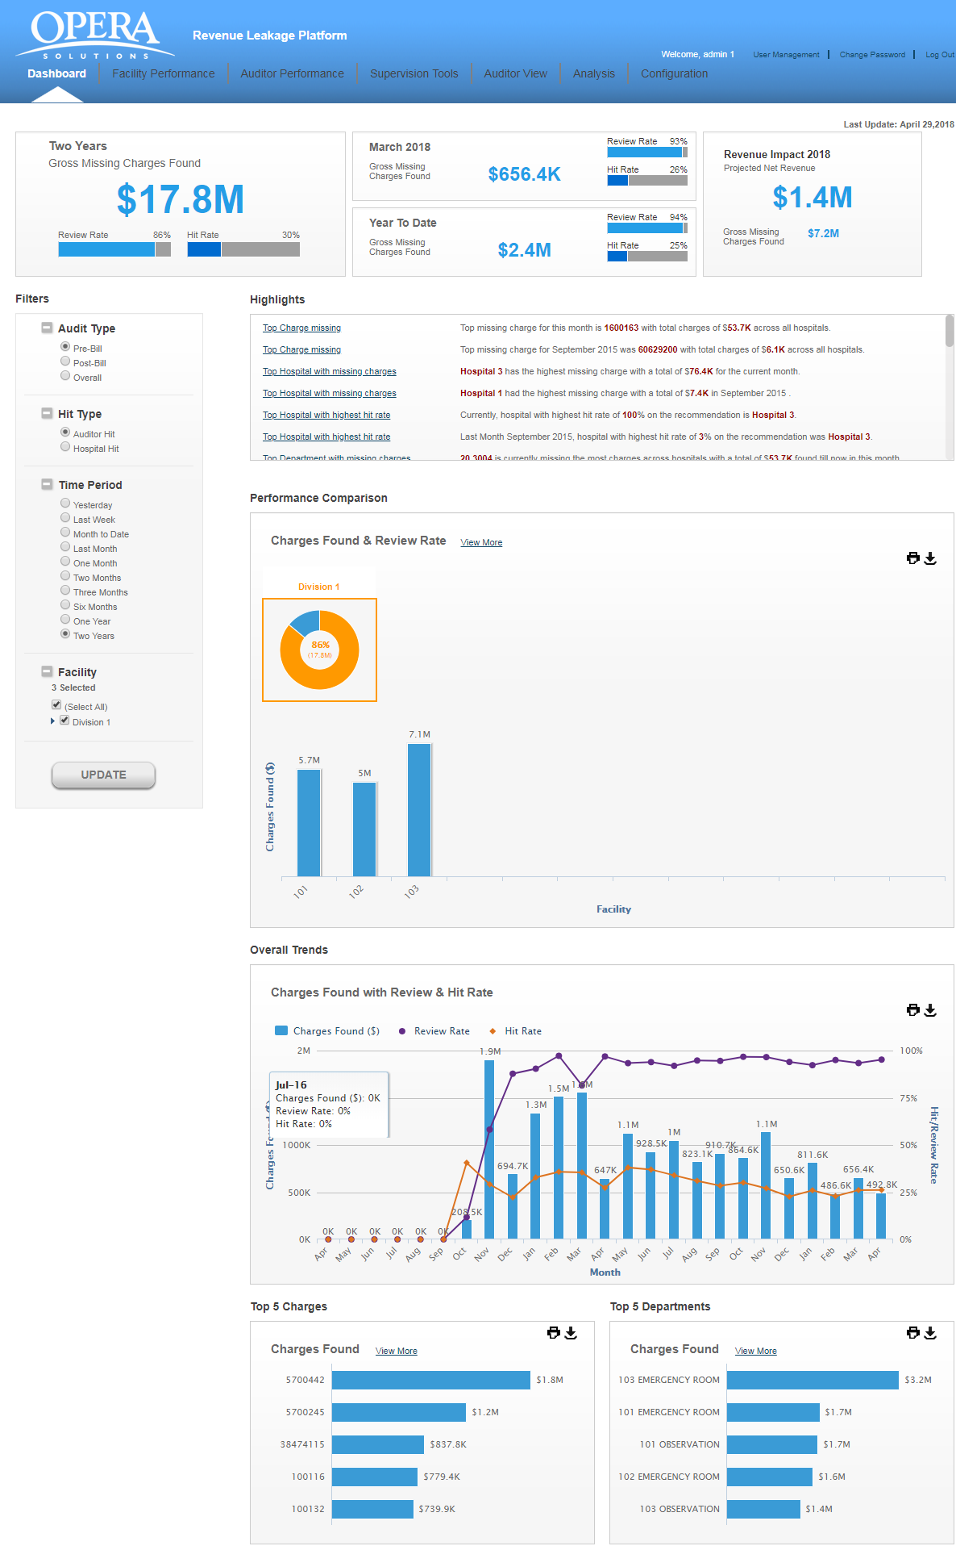The upper left corner shows the “**Gross Missing Charges Found”, “Review Rate”** and the **“Hit Rate”** across all the hospitals.

For example, if the Review Rate of an auditor is 100%, it indicates that he has reviewed all the accounts which were assigned to him.

If the Hit Rate is 83%, it indicates that the auditor agreed on 83% of accounts which he reviewed for the missing charges.

On top right corner, you will view the **“Projected Net Revenue”** and the **“Gross Missing Charges”** for the current year.

You can specify filter options to display the data. Filtering can be done based on the following parameters:

* **Audit Type**

o Pre-Bill

o Post-Bill

o Overall

* **Hit Type**

o Auditor Hit

o Hospital Hit

* **Time Period**

o Last Week

o Month to data

o Last Month

o One Month

o Two Months

o Three Months

o Six Months

o One Year

o Two Years

* **Facility**

Based on the option selected, you can view the overall trend of Missing Charges and Hit Rate across various facilities. After selecting the filter, click on the **“UPDATE”** button. The application will populate the data in different widgets.

**Highlights:** This section highlights the Top Missing Charges/Review Rate of various hospitals. For example, Top Missing Charges this month, Top Missing charges last month etc.

**Performance Comparison:** You are able to view the data of different facilities across various divisions. In this segment, you will view following two charts:

o **Donut chart:** The donut chart shows the aggregated value of the “**Hit Rate”** and the **“Missing Charges”** of various hospitals based on the filter criterion selected**.**

o **Bar chart:** The bar chart shows the data related to different hospitals which fall under a particular division. If you place your mouse over the chart, a window pops up which shows the **“Hospital Name”, Dollar found”** and the **“Review Rate”** for individual hospitals.

**Overall Trend:** You are able to view the overall trend of facilities based on the filter criterion selected.

The Missing Charges found during a time period are shown as a bar chart.

The Review Rate across a time period is shown as a line graph.

The Hit Rate across a time period is shown as a line graph.

The X-axis shows the **“Time Period”**.

The Y-axis shows the **“Charges Found”** and **“Review/Hit Rate”.**

If you place your mouse over the graph, a window pops up this provides information about the **“Charges Found”, “Hit Rate”** and the **“Review Rate”.**

**Top 5 Charges:** This widget shows the “**Top Five Missing Charges”** across different hospitals based on the charge code. If you place your mouse over the charge code, a window pops up which shows the charge details like **“Charge Code, “Charge Description”** and the **“Charges Found”.**

**Top 5 Departments:** This widget shows the “**Top Five Missing Charges”** across different hospitals based on the department or department code. If you place your mouse over the department , a window pops up which shows the charge details like **“Department”, “Hit Rate“** and the **“Charges Found”**

1. **Facility Performance**

You are able to view the performance of different hospitals based on different parameters like departments, patient types, charges and auditor. Based on the past and current performances, you can set new goals and objectives for the coming year.

The upper left corner shows the “**Gross 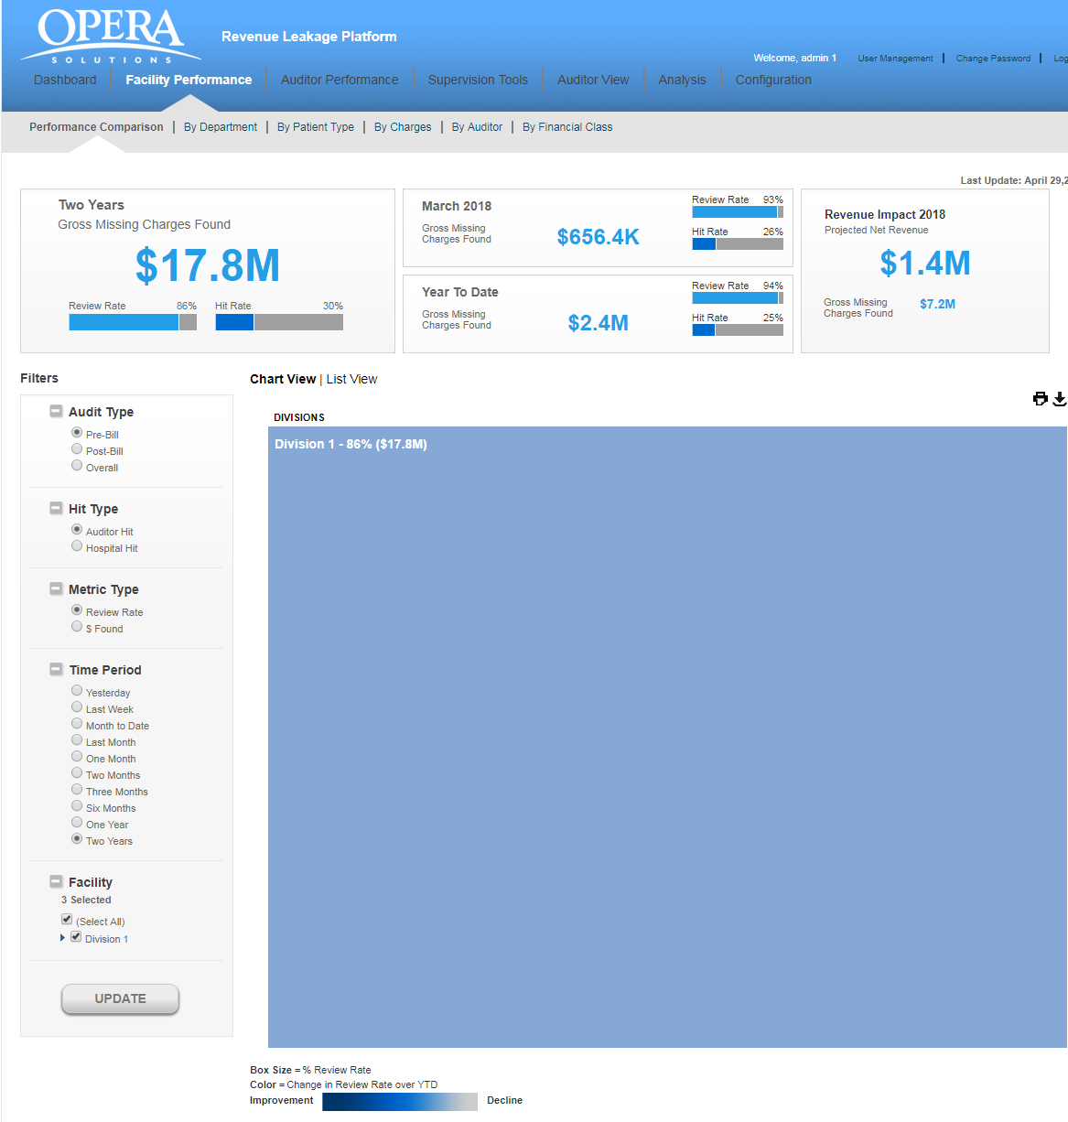 Missing Charges Found”, “Review Rate”** and the **“Hit Rate”** across all the hospitals based on selected filters (Audit Type, Metric Type, Time period and facility).

Next to it, you will view statistics for “**Review”** and “**Hit rate”** for the last month.

**“Projected Net Revenue”** is the revenue expected to be earned in future and is calculated based on the previous reporting periods.

The top right corner shows the “**Projected Net Revenue”** and the **“Gross Missing Charges”** for the current year.

You can specify filter options to display the data. Filtering can be done based on the following parameters:

* **Audit Type**

o **Pre-Bill:** If you choose this option, you will view the data for Pre-Bill accounts.

o **Post-Bill:** If you choose this option, you will view the data for Post -Bill accounts.

o **Overall:** If you choose this option, you will view the data for both Pre-Bill and Post-Bill accounts.

* **Metric Type:**

o **Review Rate:** If you choose this option, you will view the Review Rate of hospitals followed by missing charges.

o **$ Found:** If you choose this option, you will view the Missing Charges followed by Review rate of hospitals.

* **Time Period:** Select any time period from the given options**.** Based on the Time Period selected, it will display the details. For example, selecting “**Three Months”** option will display the data for last three months.

o **Last Week**

o **Month to data**

o **Last Month**

o **One Month**

o **Two Months**

o **Three Months**

o **Six Months**

o **One Year**

o **Two Years**

* **Facility:** If you choose the option **“SELECT ALL”**, all divisions and various hospitals which fall under those divisions will be selected**.** You may select a specific division for viewing the information.

After selecting the filter option, click on the **“UPDATE”** button. The data will be displayed in following two forms:

1. **Chart View:** When you click the **“Chart View”** option, you will see the filtered view of the data for selected divisions and time period.

On clicking a particular division, the application will display the data of all hospitals which fall under that division.

For example, if you select “**Metric type”** as “**Dollar Found per day”**, all the hospitals will show the “**Dollar”** amount found per day followed by “**Hit Rate”** in parentheses.

If the **Metric** selected is “**Hit Rate”**, all the hospitals will show the **“Dollar”** amount found per day followed by “**Hit Rate”** in parentheses.

The box size of various facilities\hospitals is dependent on the variance value. It is the dollar found per day over year to date period. Greater the value of dollar found, bigger would be the box size.

All the hospitals are shown in different shades and the shade is again dependent on the variance value. Higher the variance value, darker would be the shade. If you place your mouse over the box, you will view “**Dollar “found**, “**Hit Rate”** with change in average dollar found over “**Year- to- Date”** period.

2. **List View:** When you click the **“List View”** option, you will see the data of different hospitals in tabular format**.**

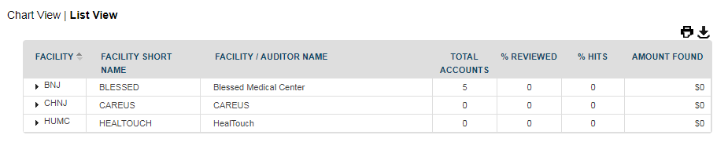

You will get the snapshot of total accounts assigned to an auditor, Accounts Reviewed, Hit Rate and the Missing Charges found across that facility. 12

5.1 By Department

When you click the option “**By Department”**, you will see the performance of different hospitals based on various departments. You can change the view by selecting the desired filters and clicking on “**UPDATE”** button.

Click any column title to change the sort order of the list. The upward triangle indicates ascending sort (A to Z and 0 to 9). The downward triangle indicates descending sort order (Z to A and 9 to 0)

Following two icons are available on right side for downloading and printing the reports.

* **Print:** The Print button () is used for taking printout of the reports.
* **Download:** The Download button is used for downloading the report in excel or PDF format.

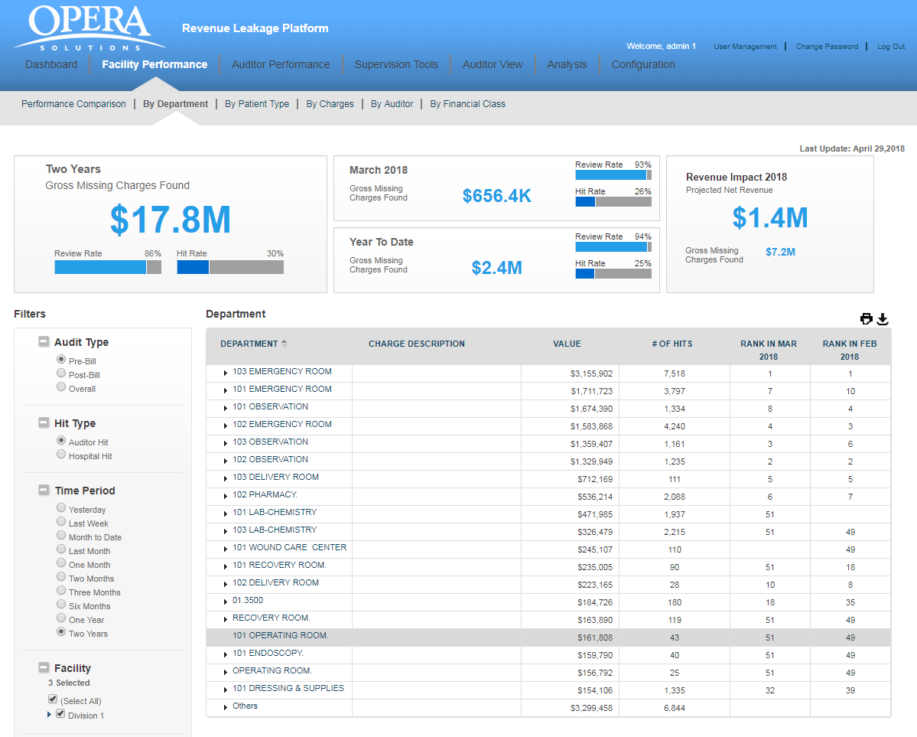

You will view various departments’ data in tabular format:

* **DEPARTMENT:** This shows the name of the department which auditor has audited.
* **$ VALUE:** This shows the missing charges found in that department.
* **# Of HITS:** This shows the number of agreed cases out of the total cases assigned to an auditor in that particular department.
* **RANK IN JUL 2013:** It shows the department ranking for last to last month.
* **RANK IN JUN 2013:** It shows the department ranking for previous month.

5.2 By Patient Type

When you click the option “**By Patient Type”,** you are able to view the performance of different hospitals based on different patient types. 14

You can change the view by selecting the desired filters and clicking on “**UPDATE”** button.

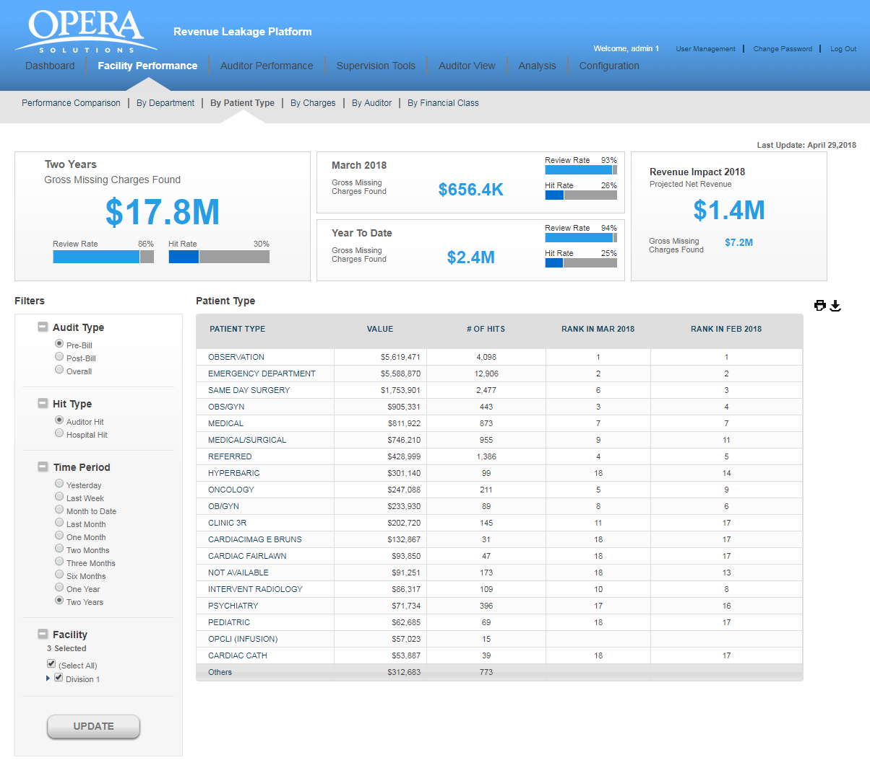

You will view the patient’s data in tabular format:

* **PATIENT TYPE:** It refers to different patient types like emergency, surgery etc.
* **$ VALUE:** These are the missing charges found for a specific patient category.
* **# Of HITS:** This shows the count of agreed cases out of the total cases assigned to an auditor for different patients.
* **RANK IN JUL 2013:** It shows the patient’s ranking for last month.
* **RANK IN JUN 2013:** It shows the patient’s ranking for last to last month.

5.3 By Charges

When you click the option **“By Charges”,** you are able to view the auditor’s performance based on different charge codes. You can change the view by selecting the desired filters and clicking on **“UPDATE”** button.

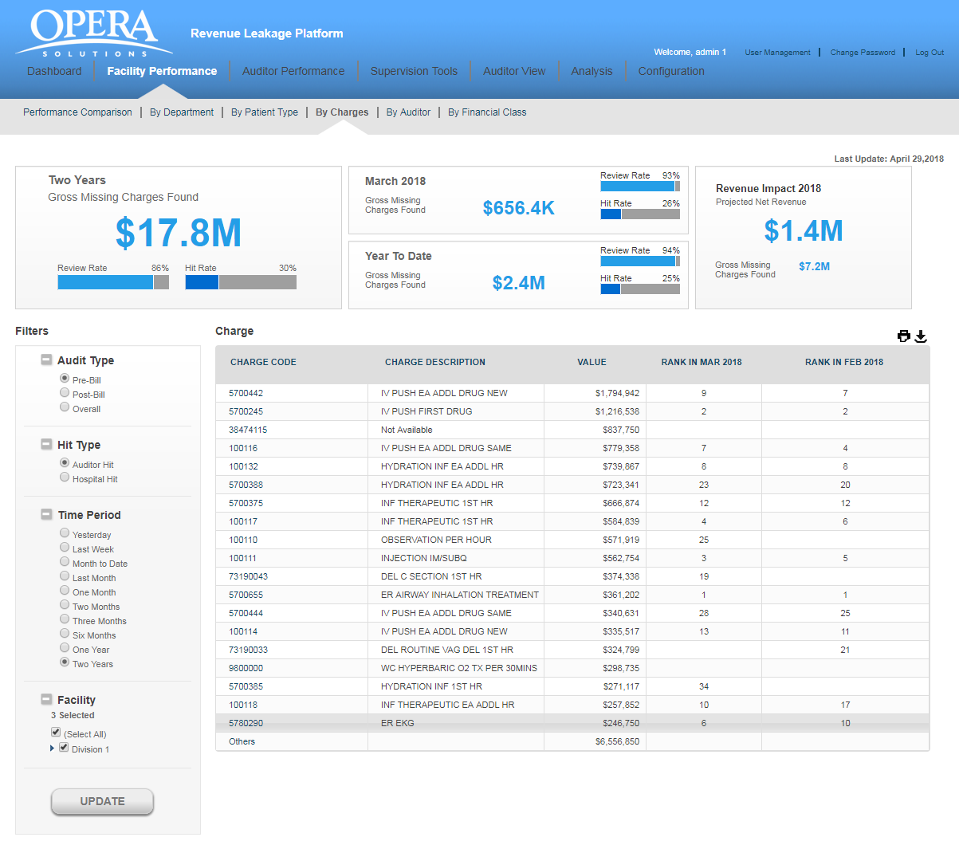

Based on the filter option selected, you can view the charge code, dollar value found against that charge code and its ranking.

5.4 By Auditor:

When you click on the option “**By Auditor**”, the application will display the comparative data of various auditors.

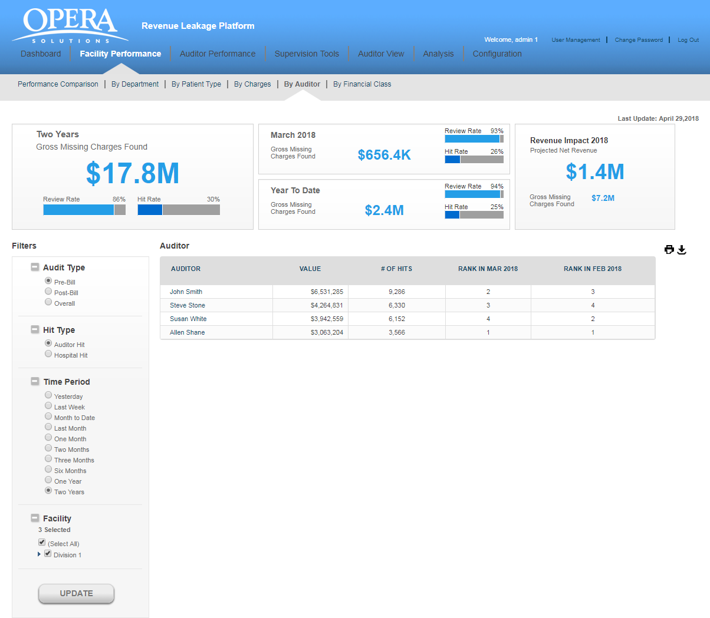

You will view the auditor’s data in tabular format:

* **AUDITOR:** This is the name of the auditor.
* **$ VALUE:** These are the missing charges found by the auditor.
* **# Of HITS:** This shows the value of agreed cases out of the total cases assigned to an auditor.
* **RANK IN AUGUST 2013:** It shows the auditor’s ranking for previous month.
* **RANK IN JULY 2013:** It shows the auditor’s ranking for last to last month.

Click any column title to change the sort order of the list.

5.5 By Financial class:

When you click on the option “**By financial class**”, the application will display the comparative data of various financial class.

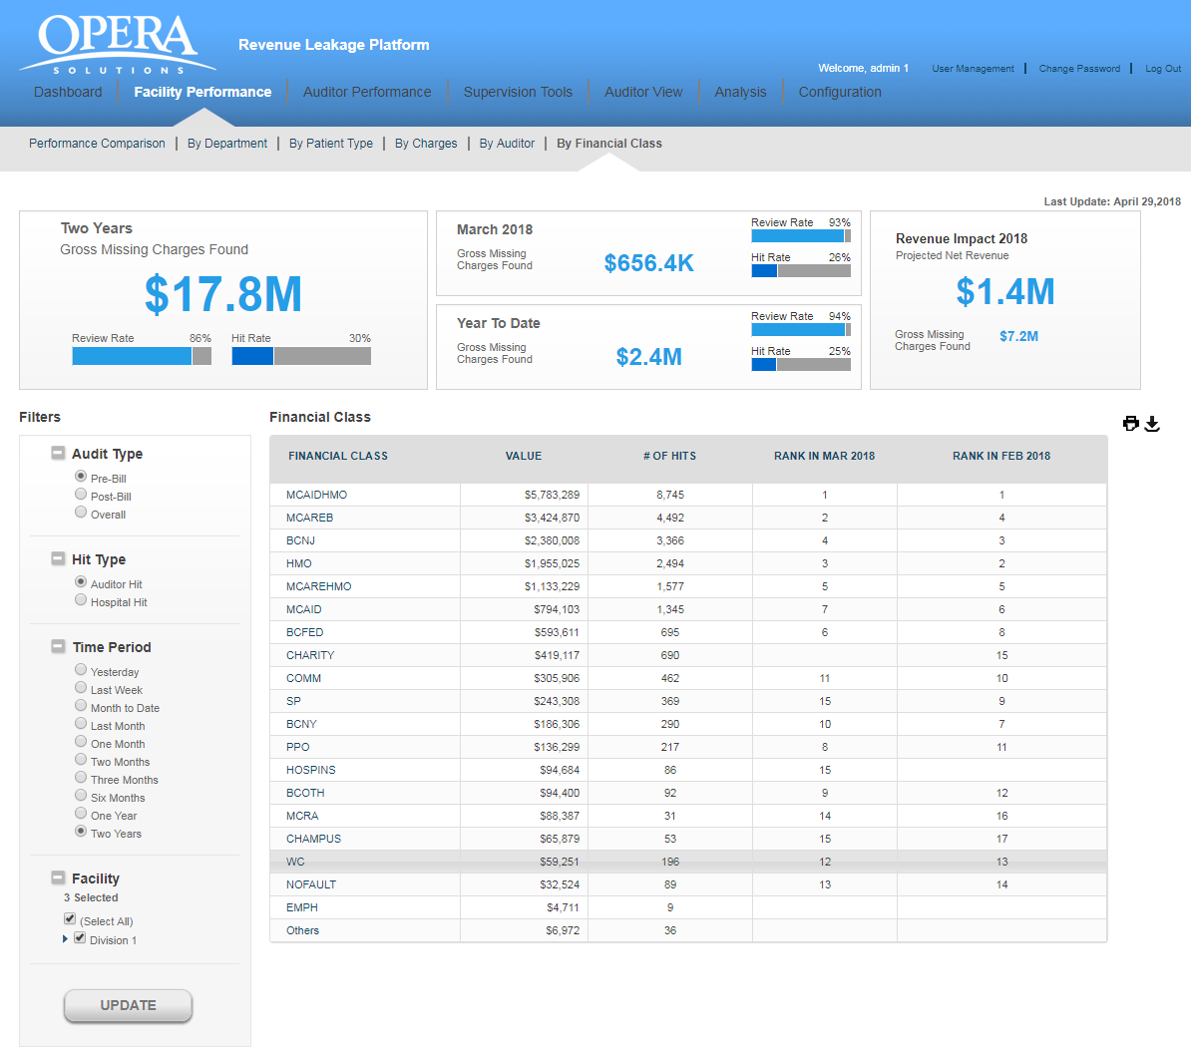

You will view the auditor’s data in tabular format:

* **FINANCIAL CLASS:** This is the name of the financial class.
* **$ VALUE:** These are the missing charges found by the auditor.
* **# Of HITS:** This shows the value of agreed cases out of the total cases assigned to an financial class.
* **RANK IN AUGUST 2013:** It shows the financial class ranking for previous month.
* **RANK IN JULY 2013:** It shows the financial class ranking for last to last month.

Click any column title to change the sort order of the list.

1. Auditor Performance

You can evaluate the performance of different auditors; track the output and measure auditor’s contribution by assessing changes across various facilities. It helps to improve auditor’s performance and achieve results.



The upper left corner shows the “**Gross Missing Charges Found”, “Review Rate”** and the **“Hit Rate”** across all the hospitals based on selected filters.

Next to it, you will view statistics for “**Review”** and “**Hit rate”** for the last month.

Top right corner shows the “**Projected Net Revenue”** and the **“Gross Missing Charges” for** the current year.

Based on the filters selected, you will be able to view and compare the Auditor’s Performance. 18

**Auditor Performance Trend:** You can view the auditor’s report chart by clicking on the tab “**Auditor Performance Trend”.** (For example, below screenshot shows the trend for the Auditor **“Cathy Pipkin”**).



**“Time Span”** is shown on the **“X axis”** and “**Charges Found”** is shown on the **“Y axis”.**

**“Missing dollars”** found across a time period are shown as bar chart.

The blue line shows the “**Review Rate”** of an auditor for the selected time period.

The brown line shows the “**Hit Rate”** for the selected time duration.

If you place your mouse over the bar graph or the line graph, a tool tip appears which shows the data for “**Charges Found”**, “**Hit Rate”** and the “**Review Rate”** for that particular month.

**Auditors Comparison**: You can compare the efficiency of different auditors by clicking on the tab **“Auditors Comparison**”. The application will display the data of all the auditors, Total Accounts assigned, Accounts Reviewed and Missing Dollars found by individual auditors.



The data is displayed in tabular format which has following columns:

* **AUDITOR NAME:** This is the name of the auditor.
* **TOTAL FACILITIES ASSIGNED:** Total facilities which are being assigned to the auditor.
* **TOTAL ACCOUNTS:** Count of all the accounts across all the hospitals which are being assigned to the auditor.
* **% REVIEWED:** This is the percentage of accounts reviewed by the individual auditor.
* **%HITS:** This is the percentage of accounts on which the auditor has agreed for missing charges.
* **$ VALUE OF HIT:** These are the missing charges found by the auditor.

Click any column title to change the sort order of the list.

1. Supervision Tools

The Supervision tools enables you to perform different operations like delegate auditors to different hospitals, examine all Pre-Bill, Post-Bill accounts and all the Missing Charges. It will uncover issues that are causing problems in various facilities and on which the action should be taken.

Clicking on “**Supervision Tools”**, displays four sub tabs:

* Live Summary
* Auditor Assignment
* Report User Assignment
* Additional auditor queue list
* New Auditor Queue
* Global Account Search
  1. Live Summary

You will tree view two types of the data in a tabular format:

* By Facility
* By Auditor

**By Facility –**

You will view the data in a tabular format which contains following columns:

* **FACILITY:** This is a unique identifier and is assigned to each facility.
* **FACILITY / AUDITOR NAME:** This is the name of the parent facility and child auditors.
* **TOTAL ACCOUNT:** This is total account in the facility. Child is showing the accounts assigned to auditor.
* **#COMPLETED:** Count of account completed by Auditors.
* **% REVIEWED:** percentage of account reviewed by Auditors.
* **# REMAINING**: Count of account remaining by Auditors.
* **# HIT ACCOUNTS**: Count of account hit by Auditors.
* **AMOUNT FOUND**: Amount found by Auditors.

**By Auditor**

You will view the data in a tabular format which contains following columns:

* **AUDITOR:** This is a unique identifier and is assigned to each auditor.
* **FACILITY NAME:** This is the name of the facility.
* **TOTAL ACCOUNT:** This is total account in the facility.
* **#COMPLETED:** Count of account completed by Auditors.
* **% REVIEWED:** percentage of account reviewed by Auditors.
* **# REMAINING**: Count of account remaining by Auditors.
* **# HIT ACCOUNTS**: Count of account hit by Auditors.
* **AMOUNT FOUND**: Amount found by Auditors.

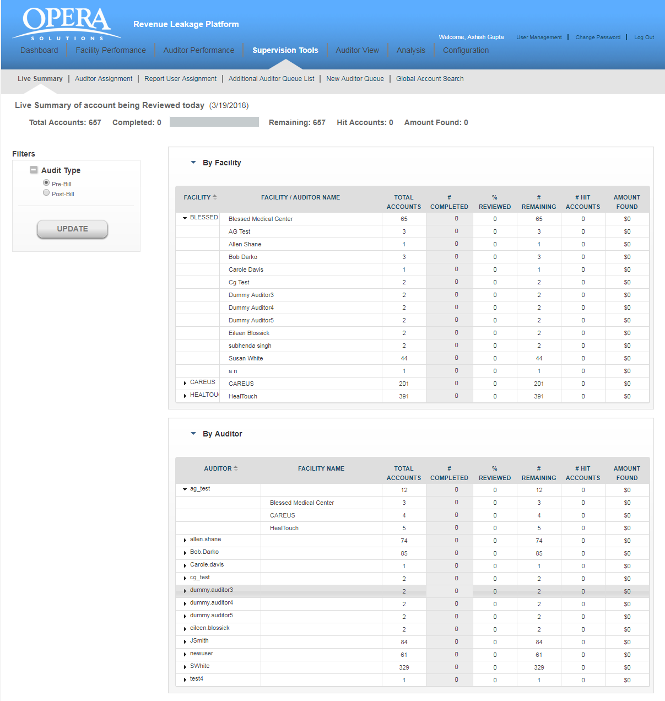

7.2 Auditor Assignment**:**

You will view the data in a tabular format which contains following columns:

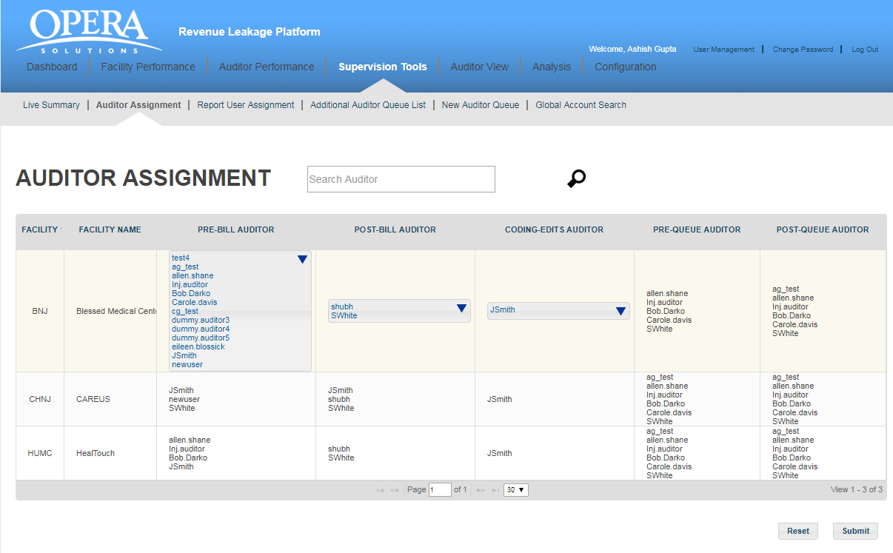

* **FACILITY:** This is a unique identifier and is assigned to each facility.
* **FACILITY NAME:** This is the name of the facility.
* **PRE-BILL AUDITOR:** This auditor is assigned for Pre-Bill accounts audit.
* **POST-BILL AUDITOR:** This auditor is assigned for Post-Bill accounts audit.
* **CODING-EDITS AUDITOR -** This auditor is assigned for rule based Pre accounts audit
* **PRE-QUEUE AUDITOR -** This auditor is assigned for Pre-queue accounts audit
* **POST-QUEUE AUDITOR -** This auditor is assigned for Post-Bill accounts audit

You can assign/unassign auditors to different hospitals depending on the requirement.

Click on the down arrow shown against the auditor’s name and you will get a complete list of auditors. Select the checkbox to the left of the auditor’s name and click **“Submit “**button. That auditor will be assigned to the facility.

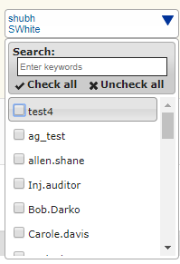

**Search:** You can use the “**Search”** box to quickly find an auditor. For example, if you want to search for the auditor” **Inj. Darko”**, type the initial letters in the text box provided, you will get a list of auditors whose first name starts with the letters you have typed. Select the auditor whose details you want to view and click on the **“Search”** button. The application will display all the hospitals which are assigned to the auditor ( **“Inj. Darko”** )

7.3 Report User Assignment:

You will view the data in a tabular format which contains following columns:

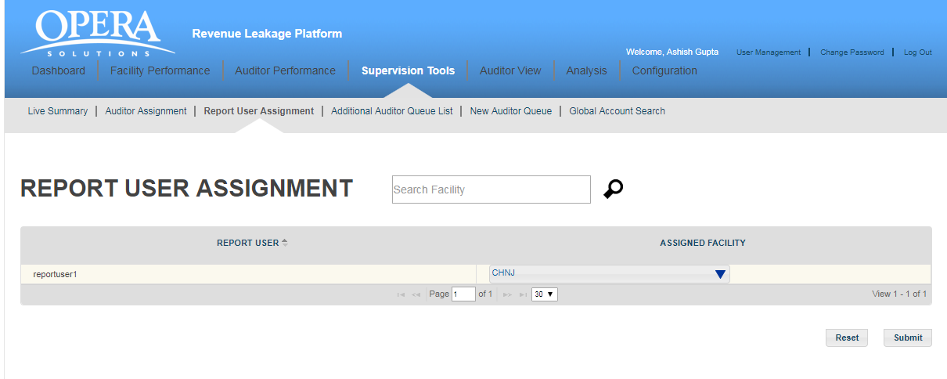

* **Report User:** This is a unique identifier and is assigned to each facility.
* **Assigned facility:** This is the name of the facility.

You can assign/unassign facility to different auditor depending on the requirement.

Click on the down arrow shown against the facility name and you will get a complete list of facility. Select the checkbox to the left of the facility name and click **“Submit “**button. That facility will be assigned to the auditor.

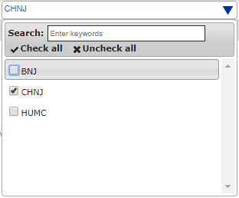

**Search:** You can use the “**Search”** box to quickly find an facility. For example, if you want to search for the facility” **BNJ”**, type the initial letters in the text box provided, you will get a list of facility whose first name starts with the letters you have typed. Select the facility whose details you want to view and click on the **“Search”** button. The application will display all the hospitals which are assigned to the facility ( **“BNJ”** )

7.4 Additional auditor Queue List:

Additional auditor queue list shows all the queues created for the application in tabular form. For searching a queue from the list, you can enter first few initials and application will show you the matching results. Also, you can update priority and assign auditor queue from here.

You will view the data in a tabular format which contains followingcolumns:

* **QUEUE NAME:** This is the name of the queue created.
* **AUDITOR:** This is the name/s of the auditor/s which are assigned for this queue.
* **BILL-TYPE:** This is the Bill-type information (PRE/POST)
* **PRIORITY:** This is the priority of the queue execution. Execution of the queue depends on the priority number; lowest number priority queue will execute at the last. So, for the queue which should execute after other queue executions should be least priority number. 
* **STATUS:** This is the status of the queue it can be active or inactive.

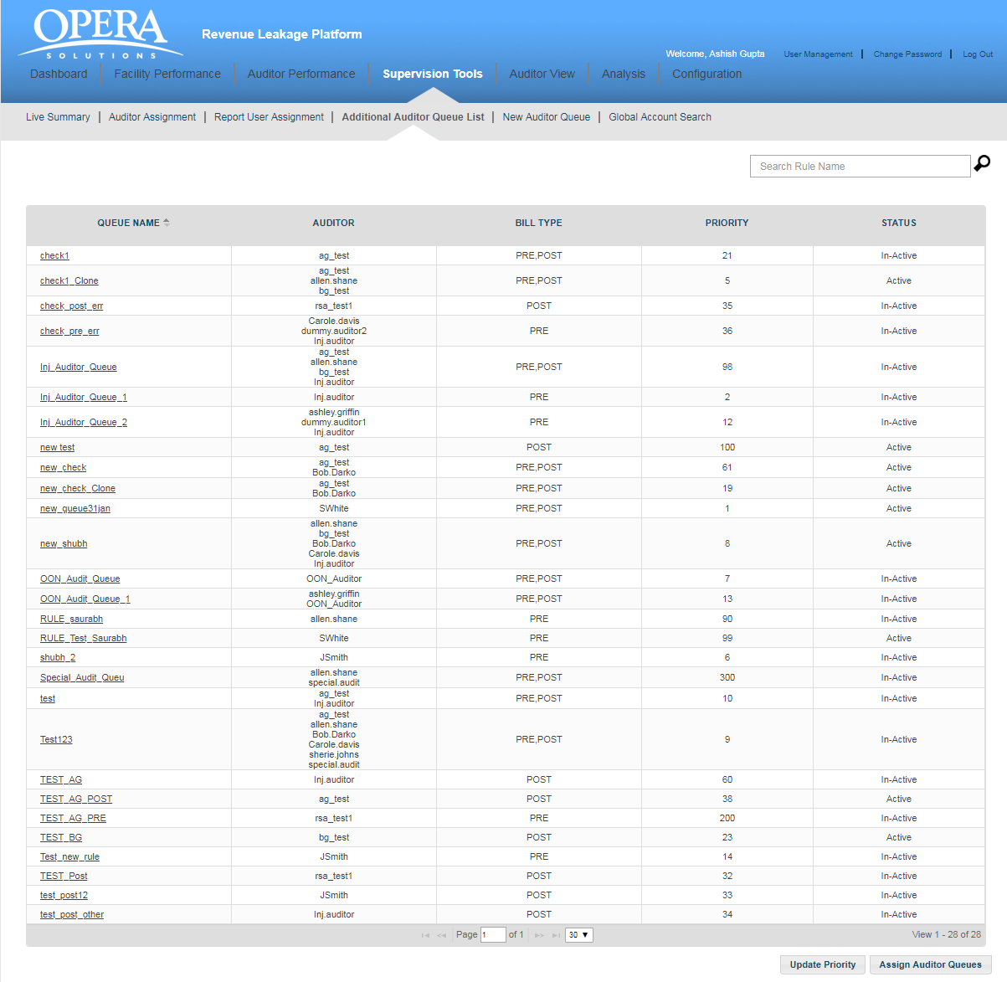

On clicking any queue name user will navigate to details screen. Here, you have “Auditor Queue Details” and “Rule Conditions” section for the queue. Administration user can only make queue active or inactive and make other modifications under “Auditor Queue Details” section, queue name field remain read only.

Administrator user can modify rule condition as per the requirement. You have following buttons available for the rule at the bottom of the screen.

* **CLONE**: Administrator user can create new queue using clone feature, if he wants to create a new queue like the existing queue, he can modify the queue name and rule condition as required for new queue.
* **PREVIEW**: User can view what all the accounts flagged as per the rule condition by using PREVIEW feature. An excel document listing all the accounts will display and accounts having rule flag is “Y” are those who satisfy this queue. Using this feature administrator can analyse created queue effectiveness before applying in the application.
* **JSON**: User can view the rule condition in JSON format using JSON feature.
* **SQL**: User can view underneath SQL query created for the rule using this button.
* **SUBMIT**: Administrator user can save changes in the queue using submit button.

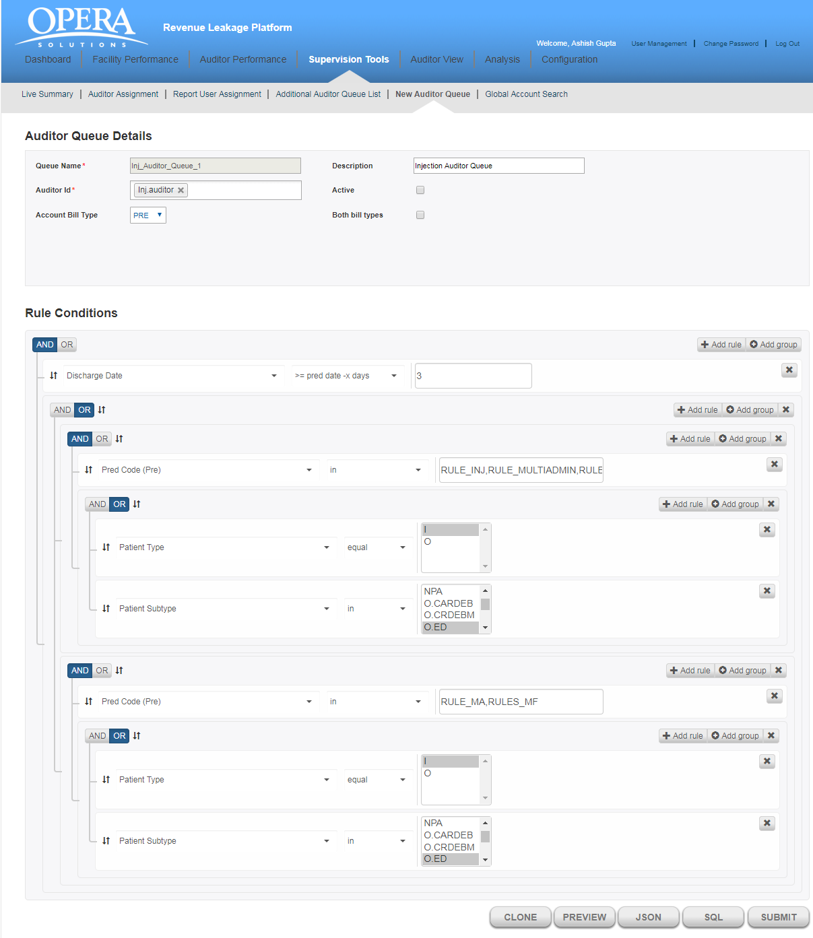

7.5 New Auditor Queue

Administrator user can create a queue using new auditor queue feature. To create a queue, user must enter some mandatory queue details and optional other information apart from the rule conditions. User can active or inactive queue as per the requirement.

You will view following fields for creating a rule.

* **Auditor Queue Details**:
* Queue Name: Here you can enter queue name. This is a mandatory field.
* Description: Description of the queue you want to create.
* Auditor Id: List of the auditors assigned for the rule. This is a mandatory field. At least one auditor is required in this field.
* Account Bill Type: Here we select bill type available in system.
* Select Table: This is the name of the table on which rule will apply. It is a prefilled drop-down where value is selected as “PREDICTIONS”.
* Active: Checkbox to make rule active for inactive.
* **Rule Conditions:** Rule condition can be a simple or nested complex rule. You can add multiple rule to make created rule satisfy multiple independent condition or can add multiple group to make nested rule. You can select rule parameter from the drop-down. Based on the selected parameter operator list will populate and on selection of the operator, depending on the operator’s nature, text field will appear to enter data and complete the rule condition.

To check and analyse the rule you can view the JSON and SQL structure of the rule condition using JSON and SQL button respectively.

After configuring the rule, you need to click on submit button to create the queue and the newly created queue will list in additional auditor queue list.

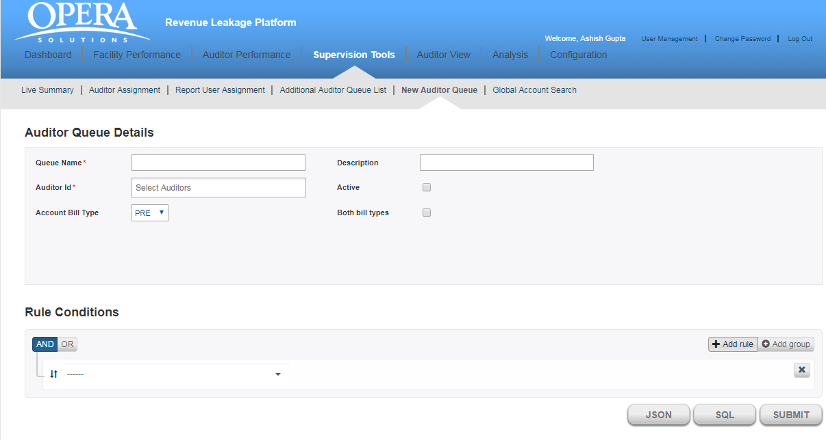

7.6 Global Account Search

Administrator user can view any account or list of accounts using global account search feature. You can directly enter account id or patient id along with facility to get the details of the account or you can select filters like facility id, patient Type, patient sub-type etc to get a list of accounts.

You will view the data in a tabular format which contains followingcolumns:

* **FACILITY:** This is the name of the facility in which account exist.
* **ACCOUNT:** Account id of the account found.
* **PATIENT TYPE:** This shows the patient type of the account. For example, outpatient, inpatient etc.
* **PATIENT SUB-TYPE:** This shows the patient sub-type of the account.
* **DISCHARGE DATE:** This shows the discharge date of the patient.
* **TRANSFER DATE:** This shows the discharge date of the account.
* **FINANCIAL CLASS:** This shows the financial class in which this account positioned.
* **SUM (PREDICTION VALUE):** Sum of the total amount predicted for this account.

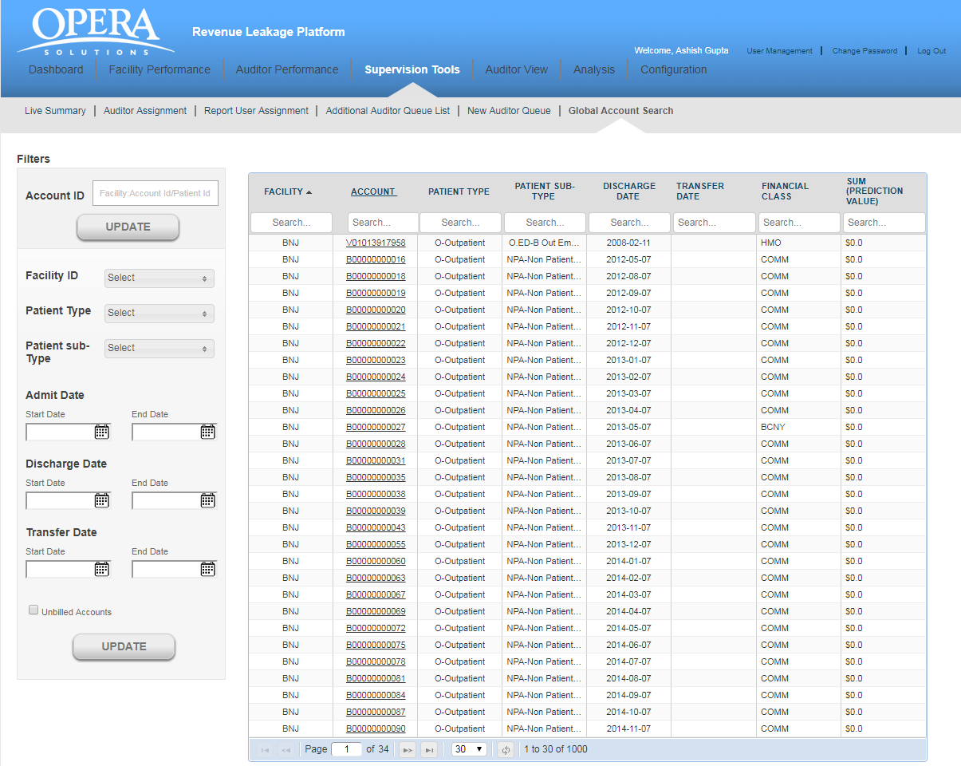

On clicking any account, you will navigate to account detail screen for the account. Here you can view all the predicted records along with the sent flag status of the predictions.

1. Auditor view

The Auditor tools enables you to perform different operations like delegate auditors to different hospitals, examine all Pre-Bill, Post-Bill accounts and all the Missing Charges. It will uncover issues that are causing problems in various facilities and on which the action should be taken.

Clicking on “**Auditor”**, displays four sub tabs:

* Pre-Bill Account Review List
* Post-Bill Account Review List
* Coding Edits
* View Confirmed Charges
* Edit Submitted Accounts
* Submitted Coding Edits

8.1 Pre Bill Account Review List

It shows all the **PRE-BILL** accounts of different hospitals which have been assigned to an   
auditor. For viewing accounts of a particular hospital, select the hospital ID and Auditor from the filter panel available on the left side and the application will display all the accounts of that particular facility.

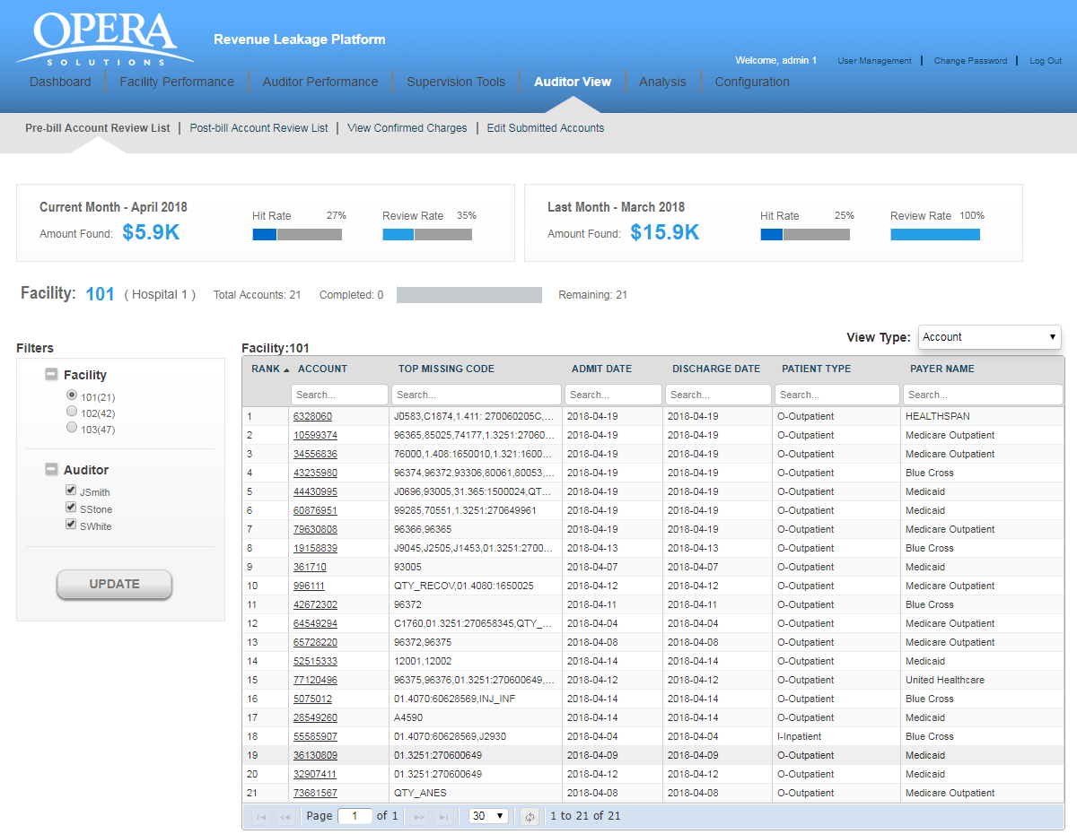

If no account is pending for review, the auditor will get the message **“No Account Review is   
 “Pending for the Facility”.**

**View Type** : Grouping accounts based on Code and payer. There are 3 options available in dropdown.

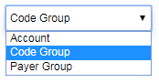

* **Account (Default)**
* **Code Group**
* **Payer Group**

**Account** : This the default view for showing accounts. accounts are coming based on hospitalId and accountId

**Code Group**: - This is showing tree view of accounts based on [hospitalId-accountid-predcodeClassifications].

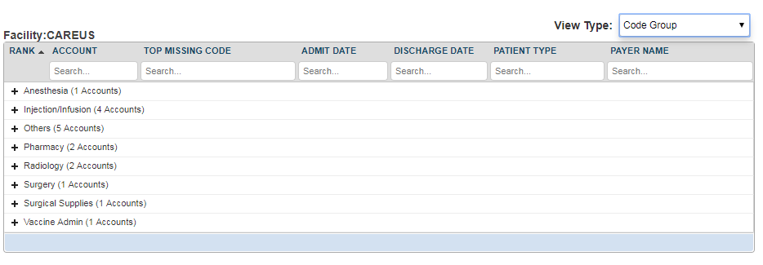

**Payer Group**:- - This is showing tree view of accounts based on [hospitalId-accountid-PayerCode].

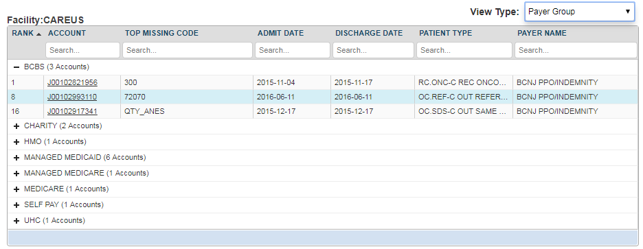

You will view the following details for a particular account.

* **Account:** It refers to the patient identification number.
* **Top Missing Code:** It refer to the missing code find for this account.
* **Admit Date:** It is the date when patient got admitted to the hospital.
* **Discharge date:** This is the date when patient got discharged from the hospital.
* **Patient Type:** There can be different types of patients. For example, OUTPATIENT, INPATIENT and EMERGENCY.
  + OUTPATIENT care is any healthcare service provided to a patient who is not admitted to a hospital.
  + INPATIENT care is any healthcare service provided to a patient who is admitted to a hospital.
  + EMERGENCY care is provided to the patients who need urgent care because of the illness or accident.
* **Payer Name:** This is the name of the insurance company.

All the above fields are searchable. You can navigate through multiple pages of records by making use of navigation bar given at the bottom of the screen. Enter a specific page number and you will jump to that specific page.

Above the account’s grid, you will view two widgets for other details like the **Amount Found**, **Hit Rate** and the **Review Rate** for the past month and the current month.



**Hit Rate:**  It refers to the percentage of accounts on which the auditor has agreed for missing charges.

The Hit Rate of an auditor can be calculated by using the below formula:

**Number of accounts Agreed / Total number of reviewed accounts**

**Review Rate:** It refers to the percentage of accounts reviewed by the auditor.

The Review Rate of an auditor can be calculated by using the below formula:

**Number of accounts Reviewed by an auditor/Total number of accounts assigned to an auditor**

# 8.2 Post Bill Account Review List

It shows all the **POST-BILL** accounts of different hospitals which have been assigned to an   
auditor. For viewing accounts of a particular hospital, select the hospital ID and Auditor from the filter panel available on the left side and the application will display all the accounts of that particular facility.

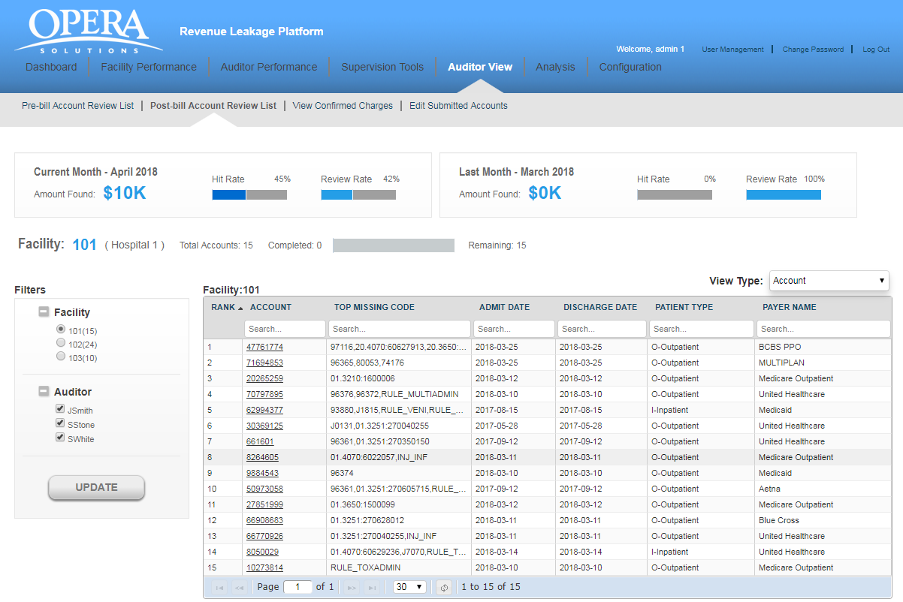

If no account is pending for review, the auditor will get the message **“No Account Review is   
 “Pending for the Facility”.**

**View Type** : Grouping accounts based on Code and payer. There are 3 options available in dropdown.



* **Account (Default)**
* **Code Group**
* **Payer Group**

**Account** : This the default view for showing accounts. accounts are coming based on hospitalId and accountId

**Code Group**: - This is showing tree view of accounts based on [hospitalId-accountid-predcodeClassifications].



**Payer Group**:- - This is showing tree view of accounts based on [hospitalId-accountid-PayerCode].



You will view the following details for a particular account.

* **Account:** It refers to the patient identification number.
* **Top Missing Code:** It refer to the missing code find for this account.
* **Admit Date:** It is the date when patient got admitted to the hospital.
* **Discharge date:** This is the date when patient got discharged from the hospital.
* **Patient Type:** There can be different types of patients. For example, OUTPATIENT, INPATIENT and EMERGENCY.
  + OUTPATIENT care is any healthcare service provided to a patient who is not admitted to a hospital.
  + INPATIENT care is any healthcare service provided to a patient who is admitted to a hospital.
  + EMERGENCY care is provided to the patients who need urgent care because of the illness or accident.
* **Payer Name:** This is the name of the insurance company.

All the above fields are searchable. You can navigate through multiple pages of records by making use of navigation bar given at the bottom of the screen. Enter a specific page number and you will jump to that specific page.

Above the account’s grid, you will view two widgets for other details like the **Amount Found**, **Hit Rate** and the **Review Rate** for the past month and the current month.



**Hit Rate:**  It refers to the percentage of accounts on which the auditor has agreed for missing charges.

The Hit Rate of an auditor can be calculated by using the below formula:

**Number of accounts Agreed / Total number of reviewed accounts**

**Review Rate:** It refers to the percentage of accounts reviewed by the auditor.

The Review Rate of an auditor can be calculated by using the below formula:

**Number of accounts Reviewed by an auditor/Total number of accounts assigned to an auditor**

# 8.3 Coding edits Accounts

It shows all the **EDITS** accounts of different hospitals which have been assigned to an auditor.

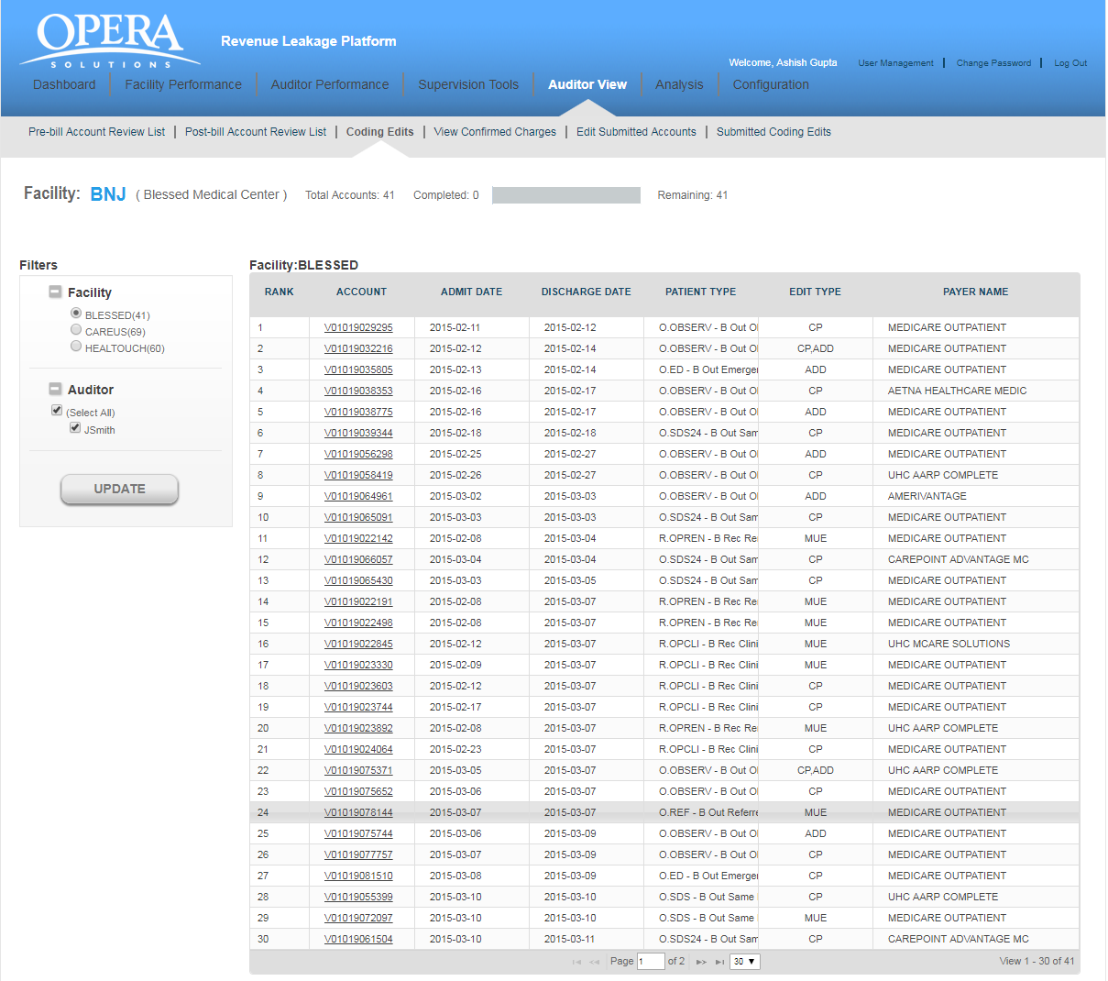

For viewing accounts of a hospital, select the hospital ID (which also shows a breakdown of accounts still to be reviewed - by each facility) and auditor from the Filter panel on the left and click on Update and the application will display all the accounts of that facility.  If no account is pending for review, the auditor will get the message “No Account Review is pending for the Facility”.

You will view the following details for an account:

* **Rank:**It refers to the rank of that particular account for review, as calculated by Opera.
* **Account:** It refers to the patient identification number.
* **Admit Date:** It is the date when patient got admitted to the hospital.
* **Discharge date:** This is the date when patient got discharged from the hospital.
* **Patient Type:** There can be different types of patients. For example, OUTPATIENT, INPATIENT

and EMERGENCY.

* + OUTPATIENT care is any healthcare service provided to a patient who is not admitted to a hospital.
  + INPATIENT care is any healthcare service provided to a patient who is admitted to a hospital.
  + EMERGENCY care is provided to the patients who need urgent care because of the illness or accident.
* **Edit Type:** There can be 3 different types of edit types. For example, CP, ADD, MUE
  + CP - These are set of rules which gives code pair which should not be present in the bill of a patient on the same date of service.
  + ADD An **add-on code** is a HCPCS/CPT code that describes a service that is always performed in conjunction with another primary service.
  + MUE - **MUE** for a HCPCS/CPT code is the maximum units of service that a provider would report under most circumstances for a single beneficiary on a single date of service.
* **Payer Name:** This is the name of the insurance company.

You can also navigate through multiple pages of records by making use of navigation bar given at the bottom of the screen.

# 8.4 View Confirmed charges

It provides a simple user interface that allows the auditors to evaluate a list of patient accounts for both PRE-BILL and POST-BILL. The auditor is able to view all the charges on which he has agreed/rejected during the auditing process and the amount of revenue likely to be recovered by addressing the missing charges. This way, the auditors can track the most important issues first. Supervisors can evaluate the productivity of their auditors. They can also see how entire hospitals are performing and accordingly assign the hospitals for both PRE-BILL and POST-BILL.

The auditor can select any option either PRE-BILL or POST-BILL. On selecting a particular option, the auditor can next select the hospitals which have missing charges.

Next we select the auditor in filter panel. Select the **“Start Date”** and the “**End Date”** and click on the “**View”** button.  The application displays the data for selected time period in the tabular format. The rows which are in blue contains those predictions which  are found on the account charges data after our prediction.  If you do not select the **“Start** **Date”** and the **“End Date”** and click on the **“Update”** button, you will get the message**“Please select both Start Date and End Date“.**You may also choose to download the data by clicking on the **Download** button.

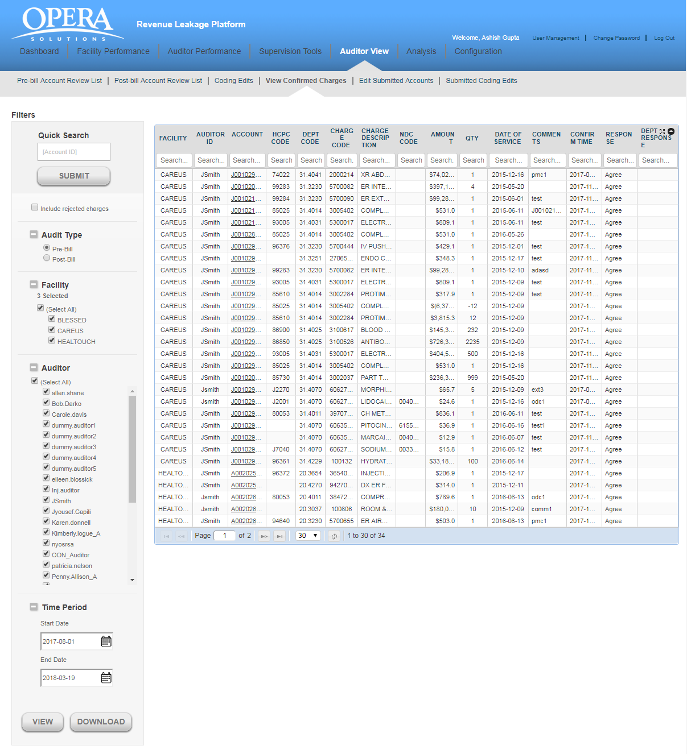

You will view the following details for each account:

* **Facility:** This is the hospital identification number.
* **Auditor ID:** This is the auditor who reviewed the prediction.
* **Account:** It refers to the patient identification number.
* **HCPC Code:** These codes are numbers assigned to every task and service a medical

practitioner may provide to a patient including medical and diagnostic services.

* **DEPT Code:** Each department in a hospital has a specific code.
* **Charge (Service) Code:** Since many procedures happen in hospitals, charge code helps to

identify different types of charges.

* **Charge (Service) Description:** This is a brief description about the charges incurred on the

patient.

* **NDC Code:** This is a code used for identifying Pharmacy charges.
* **Amount:** These are missing charges which the auditor has found for an account in a facility.
* **QTY:**This is the quantity entered by auditor for different procedures undergone by the

patient.

* **Date of Service:** This is the service date entered by the auditor when agreeing to the

prediction

* **Comments:** These are the auditor’s comments about the missing charges.
* **Confirm Time:** This is the time when auditor confirmed the missing charges.
* **Response:** This is the response from the auditor

If you do not select any hospital and click on the **“View”** button, you will get the message **“Please select at least one facility”.**

If there are no missing charges found for the selected period, you will get the message **“No charges found for the selected period”**.

# 8.5 Edit Submitted Accounts

It provides a simple user interface that allows the auditors to edit their already submitted accounts for both PRE-BILL and POST-BILL. The auditor is able to view all the charges on which he has agreed/rejected during the auditing process. If the auditor feels that a change needs to be made to the submitted accounts, those accounts can be selected and the charges changed.

**Caution:** This functionality can be only used on the same day of submission of the account before consolidated reports are sent to facilities.

The auditor can select any option either PRE-BILL or POST-BILL. On selecting a particular option, the auditor can next select the hospitals and Auditor and click on the “**Update”** button.  The application displays the data in the tabular format.

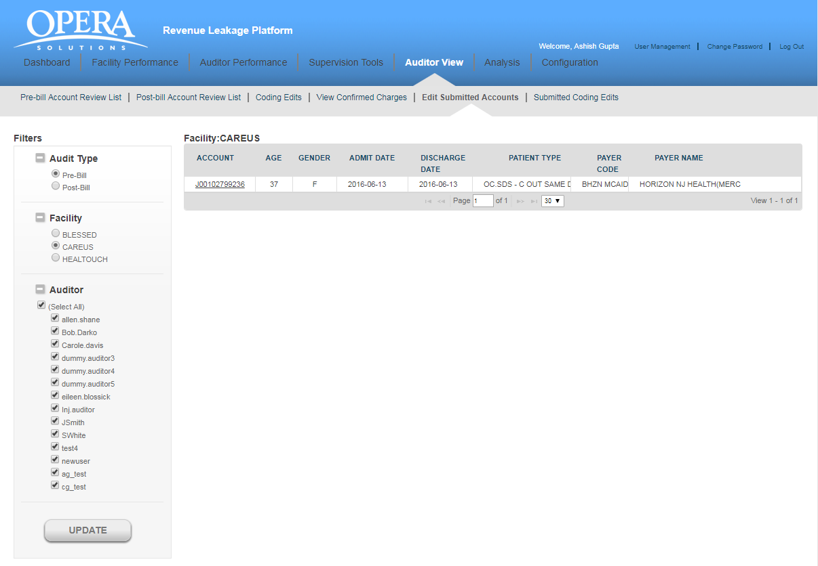

You will view the following details for each account:

* **Account:** It refers to the patient identification number.
* **Age:** It shows the age of the patient.
* **Gender:** It refers to the Gender of the patient.
* **Admit Date:** It is the date on which the patient was admitted.
* **Discharge Date:**It is the date on which the patient was discharged from the facility
* **Patient Type:**There can be different types of patients. For example, OUTPATIENT, INPATIENT and EMERGENCY.
  + OUTPATIENT care is any healthcare service provided to a patient who is not admitted to a hospital.
  + INPATIENT care is any healthcare service provided to a patient who is admitted to a hospital.
  + EMERGENCY care is provided to the patients who need urgent care because of the illness or accident.
* **Payer code:** Health care providers follow up on claims to insurance companies (payer) in order to receive payment for the services which they have rendered to the patients. The payer code refers to the insurance company code.
* **Payer Name:** This is the name of the insurance company.

If you do not select any hospital and click on the **“Update”** button, you will get the message **“Please select at least one facility”.**

If there are no account reviews found for the selected facility, you will get the message **“No account review is pending for the facility”.**

# 8.6 Submitted coding edits Accounts

It provides a simple user interface that allows the auditors to edit their already submitted accounts for CCI Edits. The auditor is able to view all the charges on which he has agreed/rejected during the auditing process. If the auditor feels that a change needs to be made to the submitted accounts, those accounts can be selected and the charges changed.

**Caution:** This functionality can be only used on the same day of submission of the account before consolidated reports are sent to facilities.

The auditor can select Facility and Auditor from filter panel. On selecting a particular option, the auditor can next select the hospitals and click on the “**Update”** button.  The application displays the data in the tabular format.

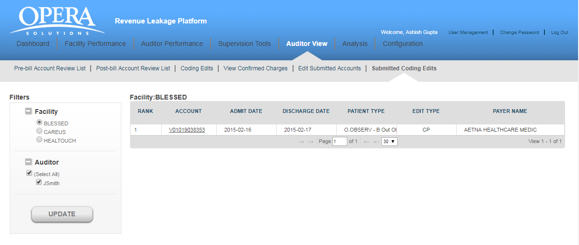

You will view the following details for each account:

1. **Account:** It refers to the patient identification number.
2. **Age:** It shows the age of the patient.
3. **Gender:** It refers to the Gender of the patient.
4. **Admit Date:** It is the date on which the patient was admitted.
5. **Discharge Date:**It is the date on which the patient was discharged from the facility
6. **Patient Type:**There can be different types of patients. For example, OUTPATIENT, INPATIENT and EMERGENCY.
   * OUTPATIENT care is any healthcare service provided to a patient who is not admitted to a hospital.
   * INPATIENT care is any healthcare service provided to a patient who is admitted to a hospital.
   * EMERGENCY care is provided to the patients who need urgent care because of the illness or accident.
7. **Payer code:** Health care providers follow up on claims to insurance companies (payer) in order to receive payment for the services which they have rendered to the patients. The payer code refers to the insurance company code.
8. **Payer Name:** This is the name of the insurance company.

You will view the following details for an account:

* **Rank:**It refers to the rank of that particular account for review, as calculated by Opera.
* **Account:** It refers to the patient identification number.
* **Admit Date:** It is the date when patient got admitted to the hospital.
* **Discharge date:** This is the date when patient got discharged from the hospital.
* **Patient Type:** There can be different types of patients. For example, OUTPATIENT, INPATIENT and EMERGENCY.
  + OUTPATIENT care is any healthcare service provided to a patient who is not admitted to a hospital.
  + INPATIENT care is any healthcare service provided to a patient who is admitted to a hospital.
  + EMERGENCY care is provided to the patients who need urgent care because of the illness or accident.
* **Edit Type:** There can be 3 different types of edit types. For example, CP, ADD, MUE
  + CP - These are set of rules which gives code pair which should not be present in the bill of a patient on the same date of service.
  + ADD An **add-on code** is a HCPCS/CPT code that describes a service that is always performed in conjunction with another primary service.
  + MUE - **MUE** for a HCPCS/CPT code is the maximum units of service that a provider would report under most circumstances for a single beneficiary on a single date of service.
* **Payer Name:** This is the name of the insurance company.

You can also navigate through multiple pages of records by making use of navigation bar given at the bottom of the screen.

Click on any account and you are directed to the “SUBMITTED CODING-EDITS ACCOUNT DETAILS” page.

1. Analysis

* Hit rate Analysis
* Volume analysis

# 9.1 Hit rate Analysis

This section gives the report based on prediction based on a certain period. like

**LW**Average of last two weeks  
**PW** Average of previous four weeks before last two weeks

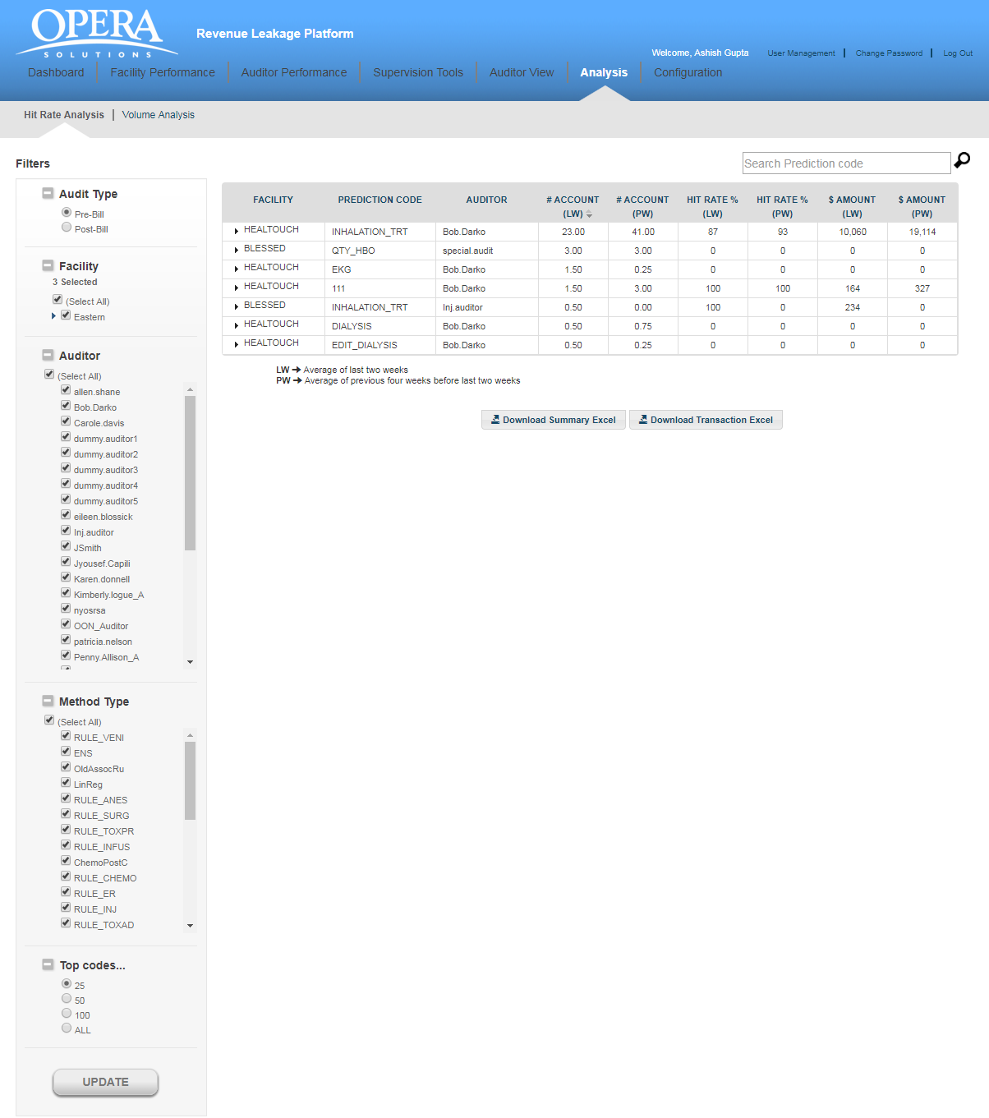

You will view the data in a tabular format which contains followingcolumns:

* **FACILITY NAME:** This is the name of the facility.
* **PREDICTION CODE:** This is the name of prediction code
* **AUDITOR:** This is the Auditor information (PRE/POST)
* **#ACCOUNT (LW):**    Average of last two-week on basis of prediction.
* **#ACCOUNT (PW):**   Average of previous four-week on basis of prediction.
* **Hit rate (%) (LW) -** Average of last two-week on basis of prediction.
* **Hit rate (%) (PW) -** Average of previous four-week on basis of prediction.
* **Amount (LW) -** Average of last two-week on basis of prediction.
* **Amount (PW) -** Average of previous four-week on basis of prediction.
  1. Volume Analysis

This will give the volume analysis on basis of account flagged on certain period of time.

Tabular data is showing the week-wise report and column chart is showing the last 5-week reports per facility. We can select filter from filter panel, it is based on bill-type. Data is showing based on selected PRE/POST from filter panel.

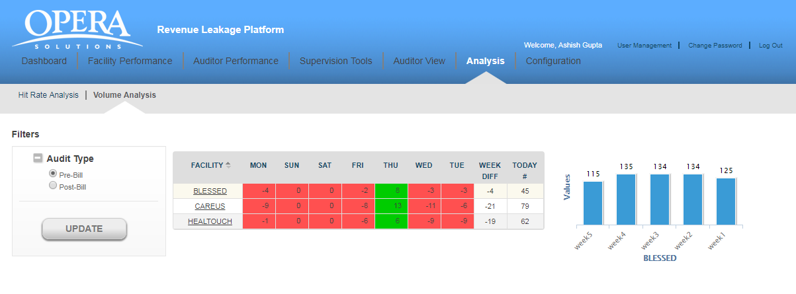

1. Configuration

This feature enables administrator user to create rule and publish new codes. Based on historical data and analysis of accounts an administrator user can create a rule which can add or supress codes when the scoring happens for the application. This feature facilitates the user to further enhance the model’s prediction capability by enforcing rules while prediction occurs for the application.

Publish new codes feature enables administrator user to publish, retract or supress predicted accounts based on account id or pred key. Based on the requirement administrator user can create a new publish code that will come into effect when the periodic backend process executes the publish code request.

Administrator user can activate or deactivate any rule or publish code. Publish code can only be used once after the execution of the code it will become inactive and you can only preview the accounts flagged by the code.

* 1. Rules Summary

Rule summary shows all the rules created for the application in tabular form. For searching a rule from the list, you can enter first few initials and application will show you the matching results. Also, you can download the list of rules in excel format.

You will view the data in a tabular format which contains followingcolumns:

* **RULE NAME:** This is the name of the rule created.
* **RULE TYPE:** This is the type of the rule it can be suppression or addition.
* **PRIMARY TABLE:** This is the name of the table on which rule will apply. It can be “PATIENT”, “PREDICTION” or “PHYSICIAN VISITS”.
* **LAST MODIFIED BY:** This is user id of the user who last modified the rule.
* **LAST MODIFIED ON:** This is the date on which the rule last modified. 
* **STATUS:** This is the status of the rule it can be active or inactive.

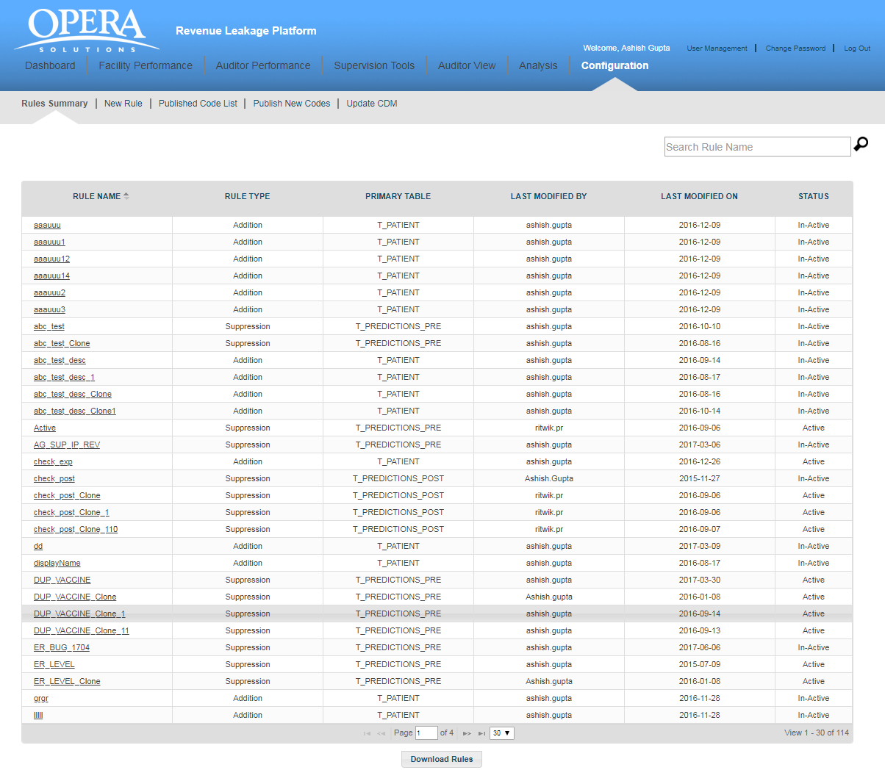

On clicking any rule name user will navigate to rule details screen. Here, you have “Rule Details” and “Rule Conditions” section for suppression type rule. For addition rules you have an additional section of “Code Details”. Administration user can only make rule active or inactive under “Rule Details” section, rest of the details remain read only.

Administrator user can modify rule condition as per the requirement. You have following buttons available for the rule at the bottom of the screen.

* + **CLONE**: Administrator user can create new rule using clone feature, if he wants to create a new rule like the existing rule, he can modify the rule name and rule condition as required for new rule.
  + **PREVIEW**: User can view what all the accounts flagged as per the rule condition by using PREVIEW feature. An excel document listing all the accounts will display and accounts having rule flag is “Y” are those who satisfy this rule. Using this feature administrator can analyse created rule effectiveness before applying in the application.
  + **JSON**: User can view the rule condition in JSON format using JSON feature.
  + **SQL**: User can view underneath SQL query created for the rule using this button.
  + **SUBMIT**: Administrator user can save changes in the rule using submit button.

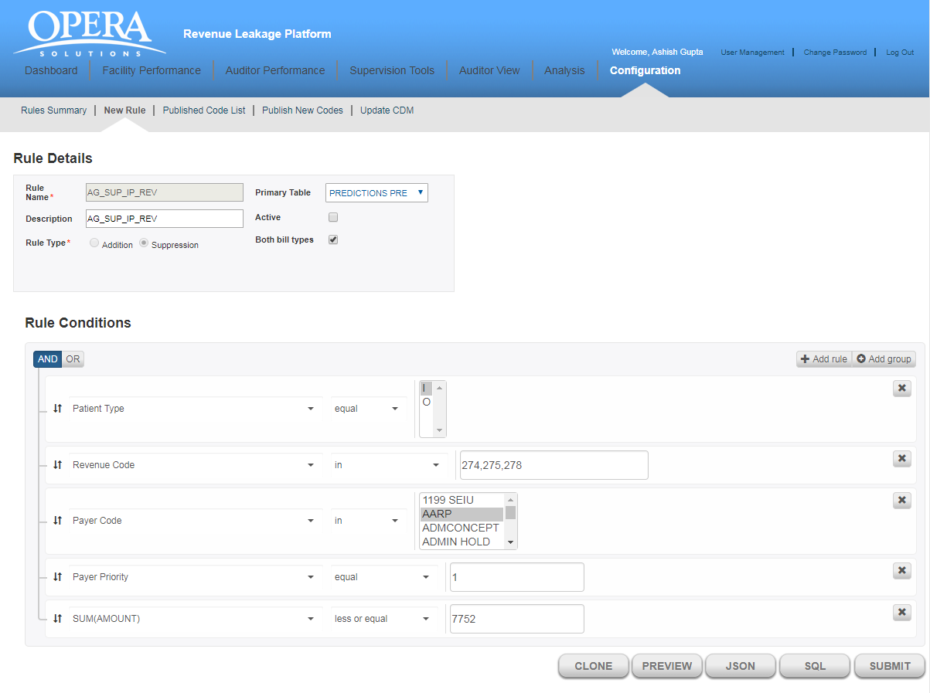

* 1. New Rule

Administrator user can create a rule using new rule feature. A rule can be suppression or addition rule. Suppression rules are those which are created to suppress predictions which satisfy the rule conditions. Similarly, addition rules are those which are created to add some additional predictions based on the rule condition when the scoring happens for the application.

To create a rule, user must enter some mandatory rule details and optional other information apart from the rule conditions. User can active or inactive rule as per the requirement.

You will view following fields for creating a rule.

* **Rule Details**:
* Rule Name: Here you can enter rule name. This is a mandatory field.
* Description: Description of the rule you want to create.
* Primary Table: This is the name of the table on which rule will apply. It has three options, “PATIENT”, “PREDICTIONS” and “PHYSICIAN VISITS”. By default, “PATIENT” is selected.
* Active: Checkbox to make rule active for inactive.
* Both Bill type: checkbox to select bill type.
* Rule Type: Rule type can be “Addition” or “Suppression”. This field depends on the selected primary table. If “Patient” or “Physician Visits” is selected than rule type should be selected as “Addition” automatically. Similarly, if “Predictions” is selected than the rule type is selected as “Suppression”. Also, in case of suppression type, “Code Details” section will disappear.
* **Code Details**: This will only show when rule type is “Addition”. It has following fields.
* Physician CPT code: Here you can enter the current procedural terminology of the physician to further refine the rule.
* Hospital HCPC code: Here you can enter the standard code to identify hospital services.
* Hospital Revenue code: Here you can enter the revenue code for the hospital services.
* Source: Here you can select one of the given source. The given sources are “GSHA” and “CPHMG”.
* Cost Center: List of cost center are available in this dropdown. Based on the rule requirement you can select a cost center.
* **Rule Conditions:** Rule condition can be a simple or nested complex rule. You can add multiple rule to make created rule satisfy multiple independent condition or can add multiple group to make nested rule. You can select rule parameter from the drop-down. Based on the selected parameter operator list will populate and on selection of the operator, depending on the operator’s nature, text field will appear to enter data and complete the rule condition.

To check and analyse the rule you can view the JSON and SQL structure of the rule condition using JSON and SQL button respectively.

After configuring the rule, you need to click on submit button to create the rule and the newly created rule will list in rule summary screen.

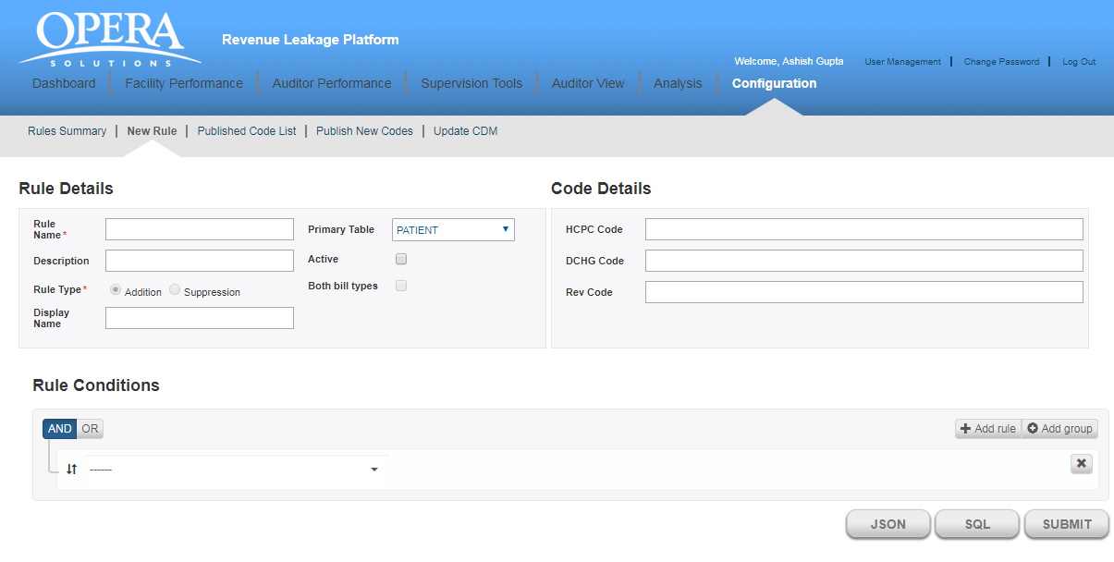

* 1. Published Code List

Published code list shows all the published code created for the application in tabular form. Codes which are already executed have run status as 1 and date and time is showing under run at column.

You will view the data in a tabular format which contains followingcolumns:

* **QUERY NAME:** This is the name of the query created. It is an auto incremented name. For example, query1, query2 etc.
* **BILL TYPE:** **:** This shows the bill type selected.
* **SENT FLAG:** This shows the type of the query created. It can be “Publish”, “Retract” or “Supress”.
* **CODE LEVEL:** This shows on which level the query applies. It can be“Pred Key” or “Account Id”.
* **STATUS:** This shows status of the query. It can be “Active” or “In-active”.
* **RUN STATUS:** This shows the run status of the query. If the query has been executed it will show “1” else it shows “0”.
* **LAST MODIFIED BY:** This is user id of the user who last modified the query.
* **LAST UPDATED ON:** This is the date and time on which the rule last modified. 
* **RUN AT:** This shows the date and time on which this query has been executed. For those queries which are not yet executed or inactive have this field blank.

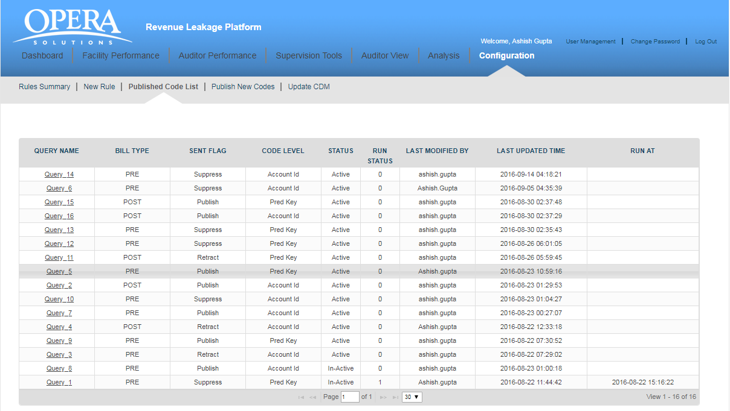

On clicking query name, you can see the query details. You can see the preview for any query but modify only those which are yet to execute.

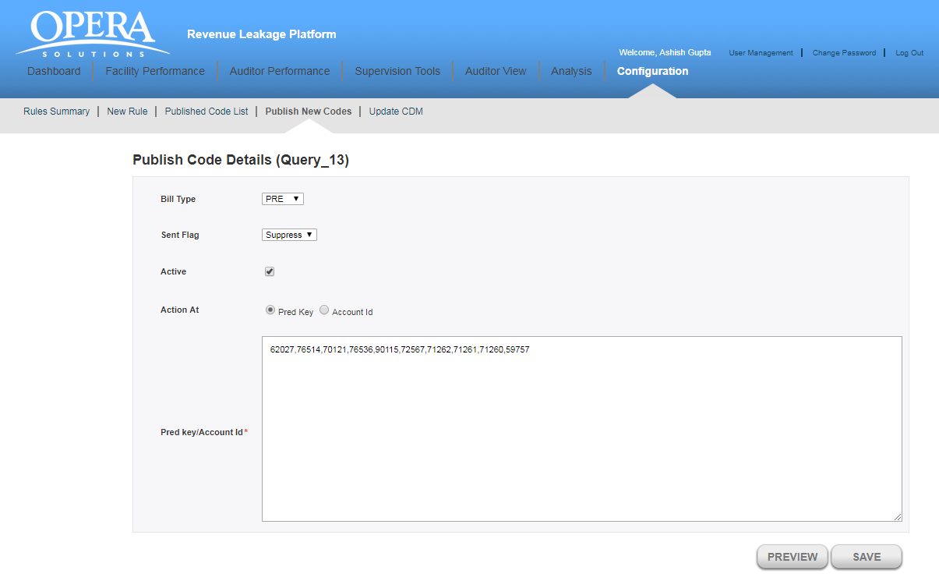

**Figure 22: Publish Code Details**

You have following buttons available for the query at the bottom of the screen.

* + **SAVE**: Administrator user can modify the details of the query which are not yet executed. Clicking on save button will save the modification and update the last update time in published code list.
  + **PREVIEW**: User can view what all the accounts flagged as per the query by using PREVIEW feature. A pop up window will show all the records along with the sent flag value, using this feature administrator can analyse created query effectiveness before applying in the application.

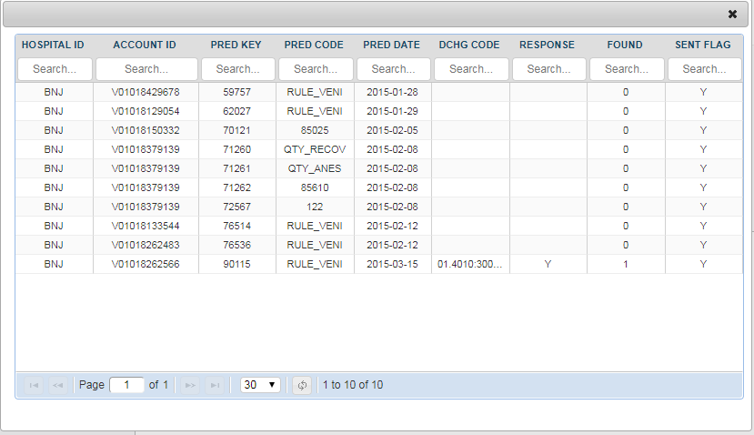

* 1. Publish New Code

Administrator user can create a new publish code using this feature. A publish code can be created for sent flag “Publish”, “Retract” or “Suppress” and it will work on list of “Pred Key” or “Account ID”. User can make the publish code active or inactive and can preview the same before enforcing in the application.

You will view following fields for creating a new publish code.

* BILL TYPE: - Here you can select bill-type.
* SENT FLAG: Here you can select the flag type.
* ACTIVE: Checkbox to make query active.
* ACTION AT: Radio buttons to select “PRED KEY” or “ACCOUNT ID”.
* PRED KEY/ACCOUNT ID: Text area where you can enter list of account id or pred keys on which code will run.

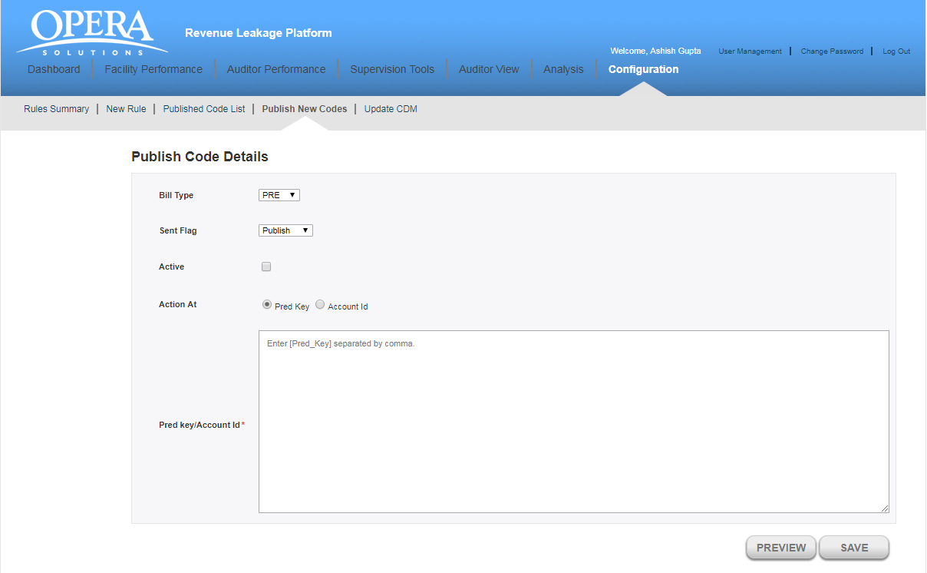

1.5 Update CDM

This section is basically used to verify/modify in charge master data. We can view, change, delete and edit the charge master data.

Below are the list of fields which can used for searching in charge master file

* Facility Id
* HCPC
* Service code
* Modifier
* Department Code
* Revenue Code
* Service Description

Initially it is giving top 1000 records in CDM file. Below screen-shot is showing the tabular data of CDM file.

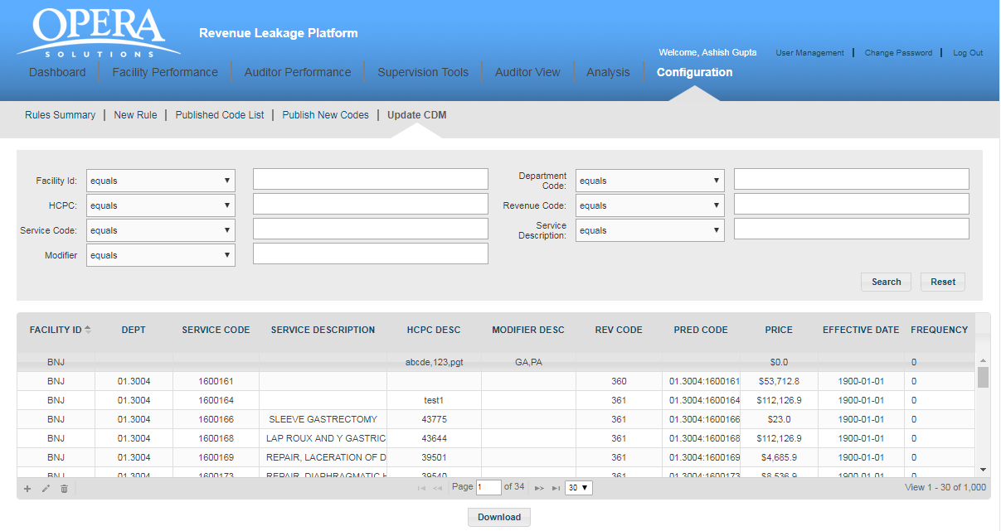

**Filter the records** – In below screen-shot we are filtering the data based on Service code (1600161).

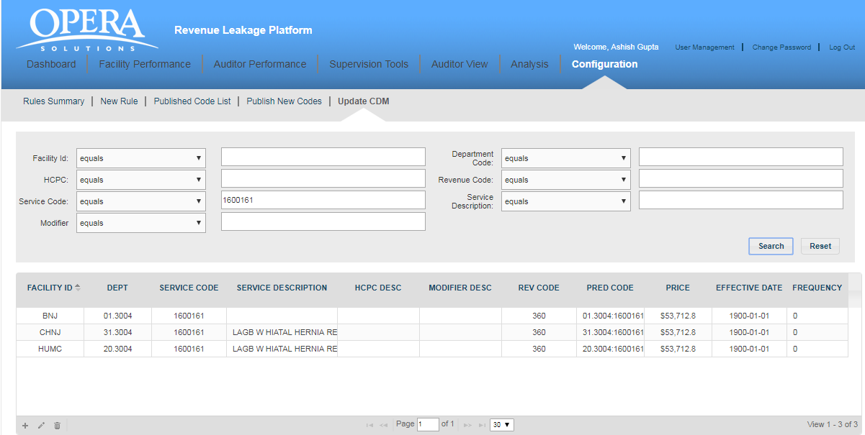

**Add, Update and Delete the CDM entry.** Below icons images are present in grid bottom-left corner.



**Adding CDM entry –**

When we click on add button of CDM, below pop-up will come. Below we have submit /cancel button.

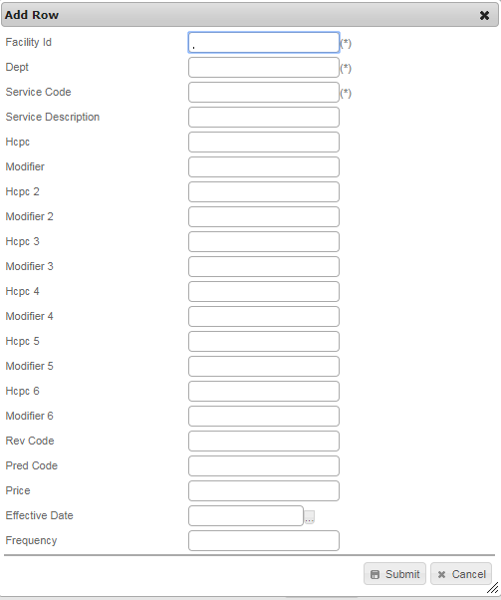

**Update CDM entry –**  We can edit any row by clicking edit button. (*) fields are read only fields. We can also navigate multiple rows using arrow button available on bottom of pop-up.

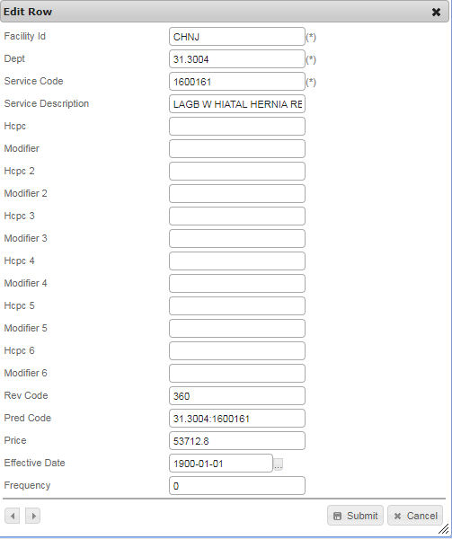

**Delete CDM entry –** We can delete any row of CDM by clicking delete icon available on bottom-left corner of the grid. We have to select row and then we are able to delete row.

